Wellbeing and Its Importance in Schools
In order to improve the mental, emotional, and social wellbeing of children and adults, understanding what makes us happy and successful has become an important focus of recent psychological research. Wellbeing science has emerged in the past few decades, providing us with empirical evidence about the conditions needed to flourish and thrive in the face of adversity (Seligman, 2011). Wellbeing has been defined as “the combination of feeling good and functioning effectively”(Huppert & So, 2011, p. 838). Martin Seligman, the father of modern positive psychology, found that those who flourish have lives rich with Positive Emotion, Engagement, Positive Relationships, Meaning, and Accomplishment, or PERMA (Seligman, 2011). The PERMA model has been updated to PERMAH, including a section on Health/Vitality (Kern, 2022). Many interventions have been developed to improve wellbeing in each of these categories and will be expounded upon hereafter in this resource. However, while traditional psychotherapy interventions focus primarily on relieving suffering, positive psychology interventions take it one step further. The field of positive psychology seeks not only to help those who flounder to function better, but also to help those who flounder and function to flourish and thrive.

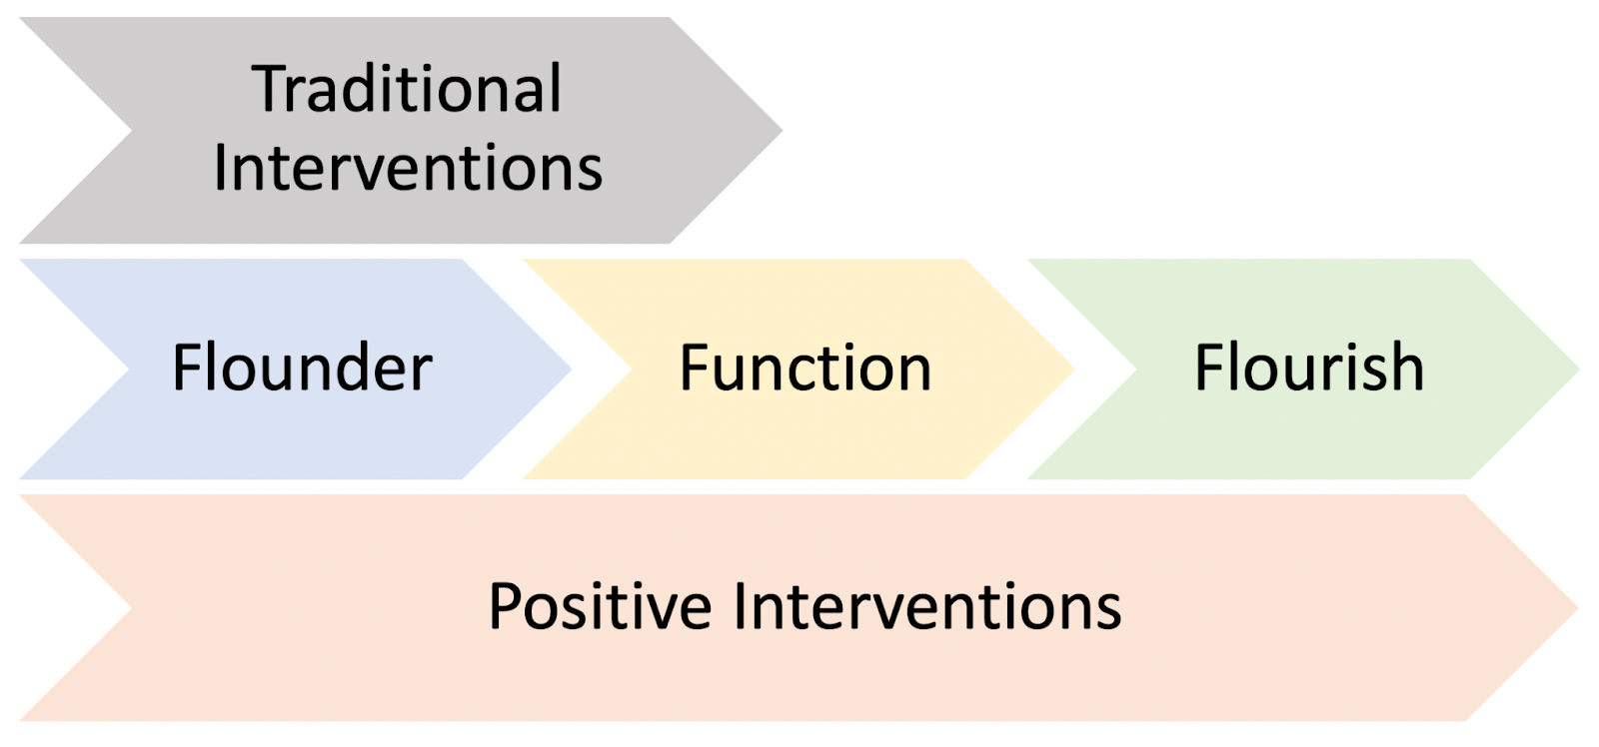

Benefits for Students
With anxiety and depression levels on the rise in our schools among both students and staff, it is important to incorporate the principles of positive psychology in our classrooms to provide our schools with opportunities to improve their psychological and social wellbeing (Centers for Disease Control and Prevention[CDC], n.d.). While some may argue that wellbeing interventions take away from valuable teaching time, the implementation of school wellbeing programs actually improve standardized test scores and academic performance (Adler, 2016). Additional studies have found that higher wellbeing is linked to higher attendance rates, higher grades, and better self control (Suldo, Thalji & Ferron, 2011; Howell, 2009).

Benefits for Teachers
Wellbeing interventions are equally important for teachers and other staff members. Teaching has developed globally as one of the most high stress professions, with high levels of burnout and teacher attrition (Learning Policy Institute, 2017; Stoeber & Rennert, 2008). Some studies have found that as many as 50% of teachers leave the profession within their first five years of teaching (Ingersoll, Merrill & Stuckey, 2014). Poor work-life balance, emotional exhaustion, little administrative support, and lack of autonomy, among other factors, contribute to lower wellbeing and enjoyment at work (Falecki & Mann, 2021; Seldon, 2018). Additionally, teacher wellbeing is directly linked to student wellbeing (Roffrey, 2012; Klusmann et al., 2016; McCallum & Price, 2010). If our teachers are unhappy, this will have a trickle-down effect to our students (Roffrey, 2012). Luckily, many studies of positive psychology-based interventions have been shown to improve teacher wellbeing, thereby improving teacher job satisfaction, stress levels and effectiveness (Falecki & Mann, 2021; Cameron, 2012; Dutton, 2003; Buckingham & Clifton, 2001).

References:
Adler, A. (2016), Teaching well-being increases academic performance: Evidence from Bhutan, Mexico, and Peru. Publicly Accessible Penn Dissertations. 1572. https://edtechbooks.org/-wsv
Buckingham, M. & Clifton, D.O. (2001). Now, discover your strengths: How to develop your talents and those of the people you manage. London: Simon & Schuster.
Cameron, K. (2012). Positive leadership: Strategies for extraordinary performance (2nd ed.). San Francisco, CA: Berrett-Koehler Publishers.
Centers for Disease Control and Prevention (CDC). (n.d.). Data and statistics on children’s mental health. Retrieved January, 6, 2022, from https://edtechbooks.org/-HoUy
Dutton, J.E. (2003). Energize your workplace: How to create and sustain high-quality connections at work. San Francisco, CA: Jossey-Bass.
Falecki D. & Mann E. (2021) Practical applications for building teacher wellbeing in education. In: Mansfield C.F. (eds) Cultivating teacher resilience. Springer, Singapore. https://edtechbooks.org/-paa
Howell, A. J. (2009) Flourishing: Achievement-related correlates of students’ well-being. The Journal of Positive Psychology, 4:1, 1-13, https://edtechbooks.org/-sQIN
Huppert, F.A. & So, T.T.C (2013). Flourishing across Europe: Application of a new conceptual framework for defining well-being. Social Indicators Research,110, 837–861. https://edtechbooks.org/-Jqiv
Ingersoll, R., Merrill, L., & Stuckey, D. (2014). Seven trends: the transformation of the teaching force, updated April 2014. CPRE Report (#RR-80). Philadelphia: Consortium for Policy Research in Education, University of Pennsylvania.
Kern, M. L. (2022). PERMAH: A useful model for focusing on wellbeing in schools. In K. A. Allen, M. Furlong, S. Suldo & D. Vella-Brodrick. (Eds.), The handbook of positive psychology in schools3rd edition. Taylor and Francis. https://edtechbooks.org/-TBGc
Klusmann U., Richter D., & Ludtke O. (2016). Teachers’ emotional exhaustion is negatively related to students’ achievement: evidence from a large-scale assessment study. . Journal of Educational Psychology, 108, 1193–1203. https://edtechbooks.org/-MBhc
Learning Policy Institute. (February, 2017). The role of principals in addressing teacher shortages. Learningpolicyinstitute.org
McCallum, F., & Price, D. (2010). Well teachers, well students. The Journal of Student Wellbeing,4(1), 19–34. https://edtechbooks.org/-XZbg
Roffey, S. (2012). Pupil wellbeing -teacher wellbeing: Two sides of the same coin?. Educational and Child Psychology, 29(4), 8-17.
Seldon, A. (2018). The fourth education revolution. UK: The University of Buckingham Press.
Seligman, M. (2011). Flourish: A Visionary New Understanding of Happiness and Well-being. New York: Simon & Schuster.
Stoeber, J., & Rennert, D. (2008). Perfectionism in school teachers: Relations with stress appraisals, coping styles, and burnout. Anxiety Stress and Coping,21(1), 37–53. https://edtechbooks.org/-xZrd
Suldo, S., Thalji, A., & Ferron, J. (2011). Longitudinal academic outcomes predicted by early adolescents’ subjective well-being, psychopathology, and mental health status yielded from a dual factor model. The Journal of Positive Psychology, 6, 17-30. https://edtechbooks.org/-GjTp

Read this online at https://open.byu.edu/addressing_wellbeing/what_is_wellbeing

