Unit 6 Scriptures
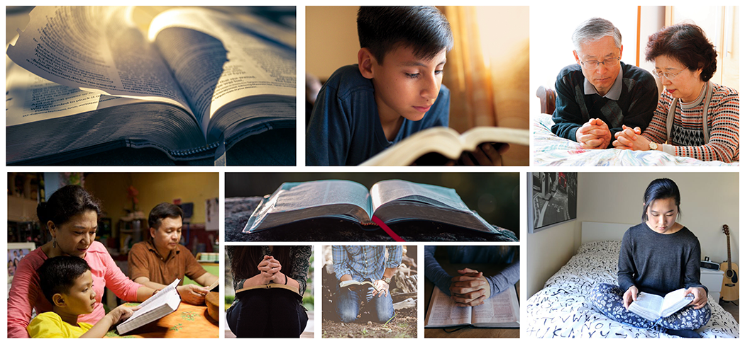

All mankind will stand before God in judgement and will be held accountable for how they treated their family

Mormon 9:14
- And then cometh the judgment of the Holy One upon them; and then cometh the time that he that is filthy shall be filthy still; and he that is righteous shall be righteous still; he that is happy shall be happy still; and he that is unhappy shall be unhappy still.

D&C 101:78
- That every man may act in doctrine and principle pertaining to futurity, according to the moral agency which I have given unto him, that every man may be accountable for his own sins in the day of judgment.

The disintegration of the family will bring upon the world the calamities foretold by the prophets

2 Timothy 3:1-7
- This know also, that in the last days perilous times shall come.
- For men shall be lovers of their own selves, covetous, boasters, proud, blasphemers, disobedient to parents,unthankful, unholy,
- Without natural affection, trucebreakers, false accusers, incontinent, fierce, despisers of those that are good,
- Traitors, heady, highminded, lovers of pleasures more than lovers of God;
- Having a form of godliness, but denying the power thereof: from such turn away.
- For of this sort are they which creep into houses, and lead captive silly women laden with sins, led away with divers lusts,
- Ever learning, and never able to come to the knowledge of the truth.

Moses 7:65-66
- And it came to pass that Enoch saw the day of the coming of the Son of Man, in the last days, to dwell on the earth in righteousness for the space of a thousand years;
- But before that day he saw great tribulations among the wicked; and he also saw the sea, that it was troubled, and men’s hearts failing them, looking forth with fear for the judgments of the Almighty God, which should come upon the wicked.

D&C 45:26- 27, 31-35
- And in that day shall be heard of wars and rumors of wars, and the whole earth shall be in commotion, and men’s hearts shall fail them, and they shall say that Christ delayeth his coming until the end of the earth.
- And the love of men shall wax cold, and iniquity shall abound.
- And there shall be men standing in that generation, that shall not pass until they shall see an overflowing scourge; for a desolating sickness shall cover the land.
- But my disciples shall stand in holy places and shall not be moved; but among the wicked, men shall lift up their voices and curse God and die.
- And there shall be earthquakes also in divers places, and many desolations; yet men will harden their hearts against me, and they will take up the sword, one against another, and they will kill one another.
- And now, when I the Lord had spoken these words unto my disciples, they were troubled.
- And I said unto them: Be not troubled, for, when all these things shall come to pass, ye may know that the promises which have been made unto you shall be fulfilled.

D&C 97:22-28
- For behold, and lo, vengeance cometh speedily upon the ungodly as the whirlwind; and who shall escape it?
- The Lord’s scourge shall pass over by night and by day, and the report thereof shall vex all people; yea, it shall not be stayed until the Lord come;
- For the indignation of the Lord is kindled against their abominations and all their wicked works.
- Nevertheless, Zion shall escape if she observe to do all things whatsoever I have commanded her.
- But if she observe not to do whatsoever I have commanded her, I will visit her according to all her works, with sore affliction, with pestilence, with plague, with sword, with vengeance, with devouring fire.
- Nevertheless, let it be read this once to her ears, that I, the Lord, have accepted of her offering; and if she sin no more none of these things shall come upon her;
- And I will bless her with blessings, and multiply a multiplicity of blessings upon her, and upon her generations forever and ever, saith the Lord your God. Amen.

D&C 101:44-54, 63-64
- A certain nobleman had a spot of land, very choice; and he said unto his servants: Go ye unto my vineyard, even upon this very choice piece of land, and plant twelve olive trees;
- And set watchmen round about them, and build a tower, that one may overlook the land round about, to be a watchman upon the tower, that mine olive trees may not be broken down when the enemy shall come to spoil and take upon themselves the fruit of my vineyard.
- Now, the servants of the nobleman went and did as their lord commanded them, and planted the olive trees, and built a hedge round about, and set watchmen, and began to build a tower.
- And while they were yet laying the foundation thereof, they began to say among themselves: And what need hath my lord of this tower?
- And consulted for a long time, saying among themselves: What need hath my lord of this tower, seeing this is a time of peace?
- Might not this money be given to the exchangers? For there is no need of these things.
- And while they were at variance one with another they became very slothful, and they hearkened not unto the commandments of their lord.
- And the enemy came by night, and broke down the hedge; and the servants of the nobleman arose and were affrighted, and fled; and the enemy destroyed their works, and broke down the olive trees.
- Now, behold, the nobleman, the lord of the vineyard, called upon his servants, and said unto them, Why! what is the cause of this great evil?
- Ought ye not to have done even as I commanded you, and—after ye had planted the vineyard, and built the hedge round about, and set watchmen upon the walls thereof—built the tower also, and set a watchman upon the tower, and watched for my vineyard, and not have fallen asleep, lest the enemy should come upon you?
- And behold, the watchman upon the tower would have seen the enemy while he was yet afar off; and then ye could have made ready and kept the enemy from breaking down the hedge thereof, and saved my vineyard from the hands of the destroyer.
- Again, verily I say unto you, I will show unto you wisdom in me concerning all the churches, inasmuch as they are willing to be guided in a right and proper way for their salvation—
- That the work of the gathering together of my saints may continue, that I may build them up unto my name upon holy places; for the time of harvest is come, and my word must needs be fulfilled.

We should seek to uphold, maintain, and strengthen families everywhere

Alma 46:12-13, 16, 19-20
- And it came to pass that he rent his coat; and he took a piece thereof, and wrote upon it In memory of our God, our religion, and freedom, and our peace, our wives, and our children—and he fastened it upon the end of a pole.
- . . . (and he called it the title of liberty) and he bowed himself to the earth, and he prayed mightily unto his God for the blessings of liberty to rest upon his brethren, so long as there should a band of Christians remain to possess the land—
- And therefore, at this time, Moroni prayed that the cause of the Christians, and the freedom of the land might be favored.
- And when Moroni had said these words, he went forth among the people, waving the rent part of his garment in the air, that all might see the writing which he had written upon the rent part, and crying with a loud voice, saying:
- Behold, whosoever will maintain this title upon the land, let them come forth in the strength of the Lord, and enter into a covenant that they will maintain their rights, and their religion, that the Lord God may bless them.

Ephesians 6:10-18
- Finally, my brethren, be strong in the Lord, and in the power of his might.
- Put on the whole armour of God, that ye may be able to stand against the wiles of the devil.
- For we wrestle not against flesh and blood, but against principalities, against powers, against the rulers of the darkness of this world, against spiritual wickedness in high places.
- Wherefore take unto you the whole armour of God, that ye may be able to withstand in the evil day, and having done all, to stand.
- Stand therefore, having your loins girt about with truth, and having on the breastplate of righteousness;
- And your feet shod with the preparation of the gospel of peace;
- Above all, taking the shield of faith, wherewith ye shall be able to quench all the fiery darts of the wicked.
- And take the helmet of salvation, and the sword of the Spirit, which is the word of God:
- Praying always with all prayer and supplication in the Spirit, and watching thereunto with all perseverance and supplication for all saints;
Read this online at https://open.byu.edu/the_eternal_family/unit_6_scriptures

