# Conclusion Paragraphs

Your conclusion paragraph should logically conclude your essay, just like your concluding sentences logically conclude your body paragraphs. The conclusion paragraph should begin by restating your thesis, and then you should broaden back out to a general topic. End with a closing statement. This paragraph looks like the reverse of your introduction paragraph, going from specific to general.

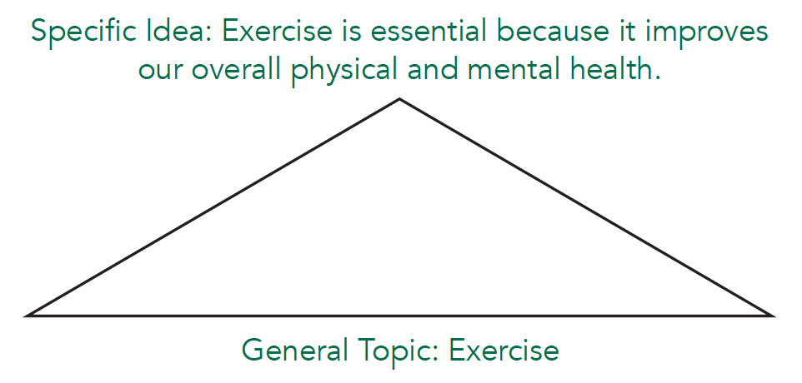

## Restate your thesis

The first sentence of your conclusion paragraph should restate your thesis. A restated thesis expresses the same idea, but the words are different. Remember that the meaning of your thesis should not change. Compare the thesis with the restatement below.

Thesis: Exercise is essential because it improves overall physical and mental health.Restated: Due to the mental and physical health benefits of exercise, it is absolutely crucial for our bodies.

### You can restate your thesis by

* changing the order of the phrases
* using synonyms (e.g., essential > crucial)
* stating main points direcly instead of implying them (or vice versa)
* using different word forms (e.g., adjective > noun)

## Apply your thesis to general contexts

Connect your thesis back to the general topics you mentioned in your introduction.

## Give a closing statement

Your closing statement is very similar to the concluding sentence of a body paragraph except that you will not restate your main idea at the very end of your paper. Your last sentences can be a prediction, suggestion, opinion, or question.

## Exercises

### Exercise 1: Identify effective restated thesis statements

Read the thesis statement. Choose the best restated thesis from the options below.

**Thesis:** Apartment complexes should provide quiet study rooms for residents so they can study without distractions.

1. Study rooms are important for students to study in.
2. Apartment managers should build quiet places to study for residents.
3. Now we can see that study rooms are valuable for students who live in apartments.
4. It is important for apartments to provide their residents with quiet study areas.

### Exercise 2: Restate a thesis

On a piece of paper, rewrite each thesis statement as you would at the beginning of a conclusion paragraph.

1. In order for students to manage stress better, they need to prioritize their tasks, eat well, and get enough sleep.
2. Even though Salt Lake City and Madrid may seem similar based on climate, their major religions, language, and food are distinct.
3. Business owners need to make decisions that satisfy employees, customers, and investors.
4. Increasing your vocabulary is easy if you try to notice new words in context, review them often, and use them as much as you can.

### Exercise 3: Write a conclusion paragraph

Read the introduction paragraph and then finish writing the conclusion paragraph on a piece of paper.

**Prompt:** Describe how to write an essay.

**Introduction:**

         Many writers feel overwhelmed when they write an essay. They are unsure of where to start or how to be successful. However, the process is very basic. There are simple steps that can simplify the process and make writing a good essay possible for anyone. In order to write an impactful essay, it is essential that writers plan, draft, and share their writing.

### Exercise 4: Identify types of paragraphs

Identify whether each paragraph is an introduction, body, or conclusion paragraph.

1.Type of paragraph: __________________________

Touchscreen technology, wireless charging, and a better camera are the best features on the new iPhone. These qualities all encourage customers to consider buying this phone because it is easier to use, more convenient, and more useful than other models. When you start looking for your upgrade, you should ask yourself if your new phone should have these features. The new iPhone does. What are you waiting for? You won’t regret upgrading to the new iPhone.

2. Type of paragraph: __________________________

A successful restaurant requires many workers, each with specific jobs that help things run smoothly. Cooks in the kitchen skillfully prepare the food. Servers take orders, deliver meals, and ensure the customers are satisfied. The hostess greets the customers as they enter the restaurant and sets the tone for the customer’s experience. All of these people are necessary to make a restaurant successful.

3. Type of paragraph: __________________________

All year long, the scenery in Utah Valley is amazing. In the winter, the valley is covered with a blanket of snow. In the spring, the trees blossom with flowers. The summer weather beckons hikers to discover the stunning vistas in the canyons. The Rocky Mountains then take on beautiful shades of red, orange, and yellow in the fall. As each season changes, the beauty of the area is evident. While all of the seasons are stunning, the most beautiful season in Utah is the autumn.

Read this online at <https://open.byu.edu/academic_a_writing/conclusion_paragraph>