# Chapter 24: Surrealism

Portions of the following text are taken from smarthistory.org, which is available for use under CC BY-NC-SA. Please see the citations at the bottom of the page for more information. The text has been adapted to more closely adhere to Chicago Manual of Style and Ensign College Style Guide.

Historians typically introduce surrealism as an offshoot of Dada. In the early 1920s, writers such as André Breton and Louis Aragon became involved with Parisian Dada. Although they shared the group’s interest in anarchy and revolution, they felt Dada lacked clear direction for political action. So, in late 1922, this growing group of radicals left Dada and began looking to the mind as a source of social liberation. Influenced by French psychology and the work of Sigmund Freud, they experimented with practices that allowed them to explore subconscious thought and identity and bypass restrictions placed on people by social convention. For example, societal norms mandate that suddenly screaming expletives at a group of strangers—unprovoked, is completely unacceptable.

Surrealist practices included “waking dream” seances and automatism. During waking dream seances, group members placed themselves into a trance state and recited visions and poetic passages with an immediacy that denied any fakery. (The surrealists insisted theirs was a scientific pursuit, unlike similar techniques used by spiritualists claiming to communicate with the dead.) The waking dream sessions allowed members to say and do things unburdened by societal expectations; however, this practice ended abruptly when one of the “dreamers” attempted to stab another group member with a kitchen knife. Automatic writing allowed highly trained poets to circumvent their training and create raw, fresh poetry. They used this technique to compose poems without forethought, resulting in beautiful and startling passages the writers would not have consciously conceived.

In the autumn of 1924, surrealism was announced to the public through the publication of André Breton’s first “Manifesto of Surrealism,” the founding of a journal (La Révolution surréaliste), and the formation of a Bureau of Surrealist Research. The literary focus of the movement soon expanded when Max Ernst and other visual artists joined and began applying surrealist ideas to their work. These artists drew on many stylistic sources, including scientific journals, found objects, mass media, and non-Western visual traditions. (Early surrealist exhibitions tended to pair an artist’s work with non-Western art objects). They also found inspiration in automatism and other activities designed to circumvent conscious intention.

Another technique, the exquisite corpse, developed from a writing game the surrealists created. First, a piece of paper is folded as many times as there are players. Each player takes one side of the folded sheet and, starting from the top, draws the head of a body, continuing the lines at the bottom of their fold to the other side of the fold, then handing that blank folded side to the next person to continue drawing the figure. Once everyone has drawn her or his part of the body, the last person unfolds the sheet to reveal a strange composite creature made of unrelated forms that are now merged. A surrealist Frankenstein’s monster, of sorts.

Whereas automatic drawing often results in vague images emerging from a chaotic background of lines and shapes, exquisite corpse drawings show precisely rendered objects juxtaposed with others, often in strange combinations. These two distinct styles represent two contrasting approaches characteristic of surrealist art and are exemplified in the early work of Yves Tanguy and René Magritte.

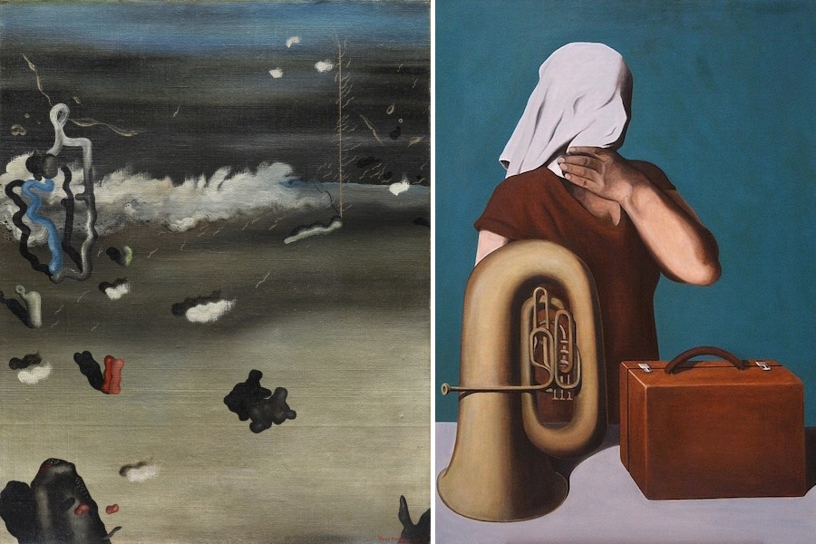

Tanguy began his painting Apparitions (left) using an automatic technique to apply unplanned areas of color. He then methodically clarified forms by defining biomorphic shapes populating a barren landscape. However, Magritte, employed carefully chosen, naturalistically presented objects in his haunting painting The Central Story. The juxtaposition of seemingly unrelated objects suggests a cryptic meaning and otherworldliness, similar to the hybrid creatures common in exquisite corpse drawings. These two visual styles extend to other surrealist media, including photography, sculpture, and film.

Today, we tend to think of surrealism primarily as a visual arts movement, but the group’s activity stemmed from much larger aspirations. By teaching how to circumvent restrictions that society imposed, the surrealists saw themselves as agents of social change. The desire for revolution was such a central tenet that through much of the late 1920s, the surrealists attempted to ally their cause with the French Communist Party, seeking to be the artistic and cultural arm. Unsurprisingly, the incompatibility of the two groups prevented any alliance, but the surrealists’ effort speaks to their political goals.

In its purest form, surrealism was a way of life. Members advocated becoming flâneurs–urban explorers who traversed cities without plan or intent, and they sought moments of objective chance—seemingly random encounters actually fraught with import and meaning. They disrupted cultural norms with shocking actions, such as verbally assaulting priests in the street. They sought in their lives what Breton dubbed surreality, where one’s internal reality merged with the external reality we all share. Such experiences, which could be represented by a painting, photograph, or sculpture, are the true core of surrealism.

### The Treachery of Images, Magritte

One of the most famous surrealist works is The Treachery of Images by René Magritte. The work presents a juxtaposition between a visual truth and a verbal truth that are in direct opposition.

**Video Transcript**

The Museum of Art, in LACMA, and we're looking at Magritte's The Treachery of Images from 1929, or also called N'est pas une pipe—this is not a pipe.

It's a hilarious painting.

It is hilarious! It's an incredibly real painting of a pipe.

Magritte paints in this incredibly wonderful matter-of-fact, kind of absolutely mundane, illustrative style.

Yes, like he was illustrating a catalog. And with the words underneath, it's as if you're looking at one of the flashcards you would have as a child where it would say . . .

That would say "pipe," but it says, "This is not a pipe"!

That's right. And, of course, he's right, it's not a pipe. It's a painting of a pipe.

But it is a pipe.

Where is the authority? Do we believe what we're seeing in the veracity of the illustration, the sort of perfect representation of the almost platonic pipe?

It's the "or" pipe, exactly. Or, do we believe the text underneath, which tells us it's not a pipe? Which is stronger, the representation of the thing or the language that denies it?

For me?

Yeah, for you.

The picture of the pipe.

The picture of the pipe is more powerful than the language?

 Yes.

That's so interesting because I think for most maybe that's because you're an art historian.

 Maybe that's why I became an art historian!

Maybe so!

I believe whatever I see.

Because so many people believe what they read, and in a sense, I think the language has a kind of authority. For me, there's this sort of perfect almost balance and struggle between the two where I just absolutely accept that pipe. It's there. It's this pipe. It's this perfect representation of a pipe. The language is completely denying it and has tremendous authority as well. And it's this fantastic tension between that presentation and then that rejection of the presentation.

Then, of course, there's the word pipe, which is, in a way, just as much an abstraction from the actual item of the pipe.

So the representation of the pipe is two-fold. There's the representation of the pipe as an image.

As an image that's iconic.

And then there's the word.

This linguistic symbol.

Yeah.

 And they're both not a pipe.

They're both not a pipe!

That's right.

They're both actually ways of representing a pipe or our notion of what that pipe is in somebody's mouth somewhere.

What else could this be a picture of? It is a pipe!

So you're denying the text.

They occupy the same area. They're both in the painting.

Okay, so when Magritte paints this, he's clearly challenging this notion of authority and which and what and it's really playful.

And also it's challenging the whole illusionistic history of Western art, right?

 No question about it.

And he's doing it again with a kind of faux naturalism, right, with this kind of self-conscious naturalism, which really sort of transcends naturalism in its sort of self-reference.

Perfectly painted and model of a pipe.

But also perfectly written text. Because the script is, again, the kind of didactic script that you would find in a kindergarten classroom, which is really meant to be instructive and meant to be full of authority. So this is a painting really about the denial of authorities of language and representation, isn't it?

I guess so.

I remember when my daughter was really little, and I woke up every morning and she looked at books with pictures just like this one, then pointed, and I had to give her the names for things.

You could have really screwed her up by giving her a book which said, "This is not a pipe"!

### The Persistence of Memory, Dali

Several Freudian concepts are useful tools for considering the strategies employed in surrealist art. In his early work, Freud concluded that dreams were often pictorial representations constructed, like poetry, by means of metaphor. The unconscious thoughts and desires at the heart of the dream were subjected to a form of censorship, which transformed their initial content into metaphor by the mechanisms of displacement and condensation.

Displacement, which Freud considered the most striking achievement of dream work, is the mechanism of substituting symbols for objects or concepts to disguise the true nature of dream thoughts. Among the common dream symbols he listed were knives and boxes as symbols for male and female genitalia, respectively.

In the mechanism of condensation, logical connections are lost or rearranged, and multiple associations may be connected to one object or image. Freud believed that the meaning of any given dream was unique, and only the dreamer, with the help of an analyst, could decipher the underlying thoughts and their significance. He also noted, however, that language and culture often determined dream symbolism and that there were common symbols to be found in many individuals’ dreams, as well as in fairytales and folklore.

**Video Transcript**

At the Museum of Modern Art, there is this tiny painting by Salvador Dali, which is the painting that everybody wants to see. That and Starry Night by Van Gogh are the two stars. We thought it would be really interesting to talk about why this painting is so wildly popular. So this is the Persistence of Memory by Salvador Dali.

And here I understand why people kind of connect to it now. I mean anybody who has ever tried to make an album for a rock band is inspired by Salvador Dali. There is also this kind of fun of, "What are you looking at?" is really playing with reality. It's kind of like a visual brain teaser.

Is that it? Is it so popular? Is it on album cover art because it's this attack on the rational and that's such a seductive idea?

Yeah, it's mind trippy. I like the way you put it. It's an attack on the rational. I guess I don't . . . There might be more to it. That's my sense.

You know, you were talking about album cover art and posters in maybe a dorm room, and what's interesting is that these artists took these ideas really seriously. This was Surrealism. This was painted in 1931. Dali, the Spanish artist, this Catalin Artist, had just come to Paris and had joined the Surrealist group.

I'm assuming he's considered significant because he was the first person to essentially do dreamscapes and, as you mentioned, attack on the rational.

When you walk into this painting visually, you enter into this really deep, open, and lonely space, and it's this really quiet image.

Yeah it's kind of this desert scape; ignoring the melting clocks for a moment, you feel that, okay, if you were in this landscape, yes, time really does not really carry a lot of weight. You could just kind of wither there and die and no one would care. Even that kind of water in the background. There's no waves in it. It's like they've had time to settle down. There's literally no activity.

There's this unbearable sense of quiet. There is almost no movement, and I think it does feel very desert-like, very hot. Literally, time has melted, right? But we have this absurd environment. We do have this very naturalistic rendering, but the things that are being rendered are not naturalistic at all. You mentioned the dead tree on the left, but it's growing out of something that seems clearly manmade or at least geometric, a table top perhaps. You have ants that seem to be eating and attracted to a piece of metal as opposed to a piece of rotted flesh.

Oh, that's what that is. I couldn't fully make it out. Okay, so they're eating away at a timepiece. That's fascinating.

And, of course, you have the drooping clocks. And that's such an interesting and provocative idea because time is something that is so regimented. Time is something that rules us, that is so associated with the industrial culture that we live in, and here, it responds to the environment as we respond to the environment.

Well, one you have that tabletop. There's another one in the background. And even the way the light is set up, especially on the cliff, it looks like it's sunset, so it's kind of like, "Hey, another day has passed, who cares?"

Now there are some identifiable things. For all the absurdity and for all of the impossibility of what we're seeing, there are some things that our historians have recognized. The cliffs in the back are, we think, the cliffs of the Catalonian coast in Northern Spain, where Dali is from, and so this is his childhood, perhaps. Some art historians have concluded that that strange figure, almost a profile face. Can you make out an eye with extremely long lashes and perhaps a tongue under the nose?

This is the whole optical illusion part of Dali. Yeah, I thought it was a blanket but now I completely see the eyelashes. I thought it was a duck for a second too. I see the eyelashes and the top of a nose.

Yeah, Dali does that fun thing where one object can actually be several things at once, sometimes really convincingly. Some art historians think this is his face, but elusive and very much a kind of dream.

That goes back in the category of is this more that kind of dorm room optical illusion type art?

Well, that's right. Surrealism posited to that, the rational world that we have so much faith in, was perhaps not worthy of all that faith. The irrational was just as important but was something that we had sublimated, something that we had tried to drive out of our life. And the way that these artists and writers thought about it was if only they could retrieve the world of the dream. Some of the artists have read Freud. Some of them had only heard sort of secondhand accounts of Freud. But the idea that the dream was a place where the irrational mind came to the fore unrestricted.

This is something that often confronts me. Even the notions that how we perceive what we think is objective reality is really based on how our brain is wired. We see these causes and effects. We see linear time. This is how humans are wired. I think that's what's fun about these type of things. Look, there are different forms of reality, and who are we as creatures that are wired one particular way to be all that judgmental about what's real.

When people have looked at this painting, they have sometimes, I think unconvincingly, tried to link it to fine signs earlier, ideas of the time dilation.

Exactly, and time, in fact, was not a strict thing. I think there is more evidence that Dali is thinking about, ideas of a philosopher whose name who is Berkson, who thought about time as something that was not simply what struck on a clock, but that there was something that kind of unit of time that was more subjective and that expanded and contracted according to our experience.

Time is this thing that sometimes scares us. We completely don't understand it, even though it's kind of the most fundamental component of our existence. We fundamentally don't understand it. We try to measure it out. We try to constrain it and define it in some way that makes sense to us. Actually, I think that's what this piece is maybe trying to do. It's like, "Look, these clocks are stupid." These are just our futile attempts to try to label. It's kind of like if you label something or you measure something, you feel like you actually understand it even though you don't.

I think this is that moment when all of those safe ideas of objectivity are being blown out of the water and we're seeing an art that is in some really interesting ways confronting that.

Read this online at <https://open.byu.edu/history_of_the_fine_arts_music/surrealism>