Compound Sentences

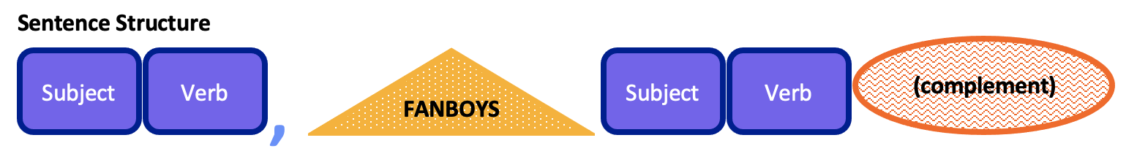

Independent Clauses
A simple sentence can also be called an independent clause. An independent clause is a subject and verb that is a complete idea. It does not need more information to complete the thought.
You can connect separate independent clauses (simple sentences) using a coordinating conjunction. Coordinating conjunctions are words that connect the two sentences together. You use them when the ideas in the sentences are connected.
- I have a dog, and I want another dog.
See that both sentences are complete. You can separate them with a period. However, the meaning of the sentences is connected, so you can use a coordinating conjunction to make the connection clear. When a sentence has more than one independent clause, it is called a compound sentence.

Coordinating Conjunctions
Coordinating conjunctions in English are for, and, nor, but, or, yet, and so. We often use the word FANBOYS to remember these words. When you use a coordinating conjunction (FANBOYS), you will use a comma before the second independent clause.
- F – Bring an umbrella,for it will rain this afternoon.
  - This word shows a cause or reason connection.
  - This is more formal and not common.
- A – Reading class is first, and writing class is second.
  - This word shows addition, time order, or cause/reason.
- N – I never liked broccoli,nor will I ever like it.
  - This shows that both clauses are not true or do not happen.
  - This is use more in formal English.
- B – Rei was late to class,but he did participate.
  - This shows a difference connection.
- O – My classmates are going to karaoke, or they are going bowling.
  - This word shows a choice between the clauses.
  - It is often used in questions.
- Y – I did the homework, yet I still have many questions.
  - This word is used like but to show a difference connection.
- S – We need money, so we will get jobs.
  - This conjunction shows a cause or reason connection like for.

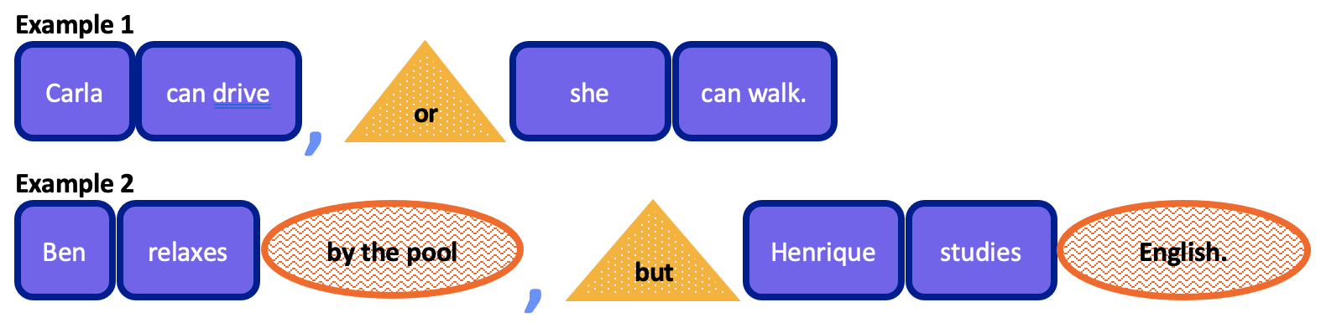

Exercise 1: Choose the Best FANBOYS Conjunction

Each sentence is missing a coordinating conjunction. Choose the correct FANBOYS word (for, and, nor, but, or, yet, so).
- I wanted to study, ______ my friends invited me to dinner.
- He studied all night, ______ he failed the test.
- We can go to the park, ______ we can watch a movie.
- The class ended early, ______ I stayed to ask questions.
- I was tired, ______ I kept working.
- She has never been to Japan, ______ has she visited Korea.
- He forgot his umbrella, ______ it rained all day.
- I took the bus, ______ I arrived on time.

Exercise 2: Combine the Sentences

Each pair of sentences can be combined into one compound sentence using a coordinating conjunction. Use a comma and choose the correct FANBOYS word.
- I like pizza. I don’t like pasta.

- She arrived late. She joined the meeting quickly.

- We went to the museum. We had lunch after.

- My car is old. It still runs well.

- He didn’t study. He passed the exam.

- The teacher was speaking. The students were listening.

- The café was busy. We found a table.

- You can take the train. You can ride the bus.

Each sentence has two independent clauses. Underline both independent clauses. Circle the coordinating conjunction.
- I have a dog, and I want another dog.
- Reading class is first, and writing class is second.
- My classmates are going to karaoke, or they are going bowling.
- Rei was late to class, but he did participate.
- I did the homework, yet I still have many questions.
- We need money, so we will get jobs.
- I never liked broccoli, nor will I ever like it.
- Bring an umbrella, for it will rain this afternoon.

Read this online at https://open.byu.edu/foundations_c_writing/compound_sentences

