The Lamentation from the Church of Saint Panteleimon

Introduction
The Lamentation is one of many frescoes in the Church of Saint Panteleimon in Gorno Nerezi in Northern Macedonia. Constructed in the 12th century, the building is a relic of late Byzantine art and architecture. In particular, the frescoes challenge the assertion that Giotto's frescoes from 14th century Padua departed from the so-called Byzantine otherworldly depiction of the human body. The Lamentation is an artistic fusion of life and death with significant emotional content.
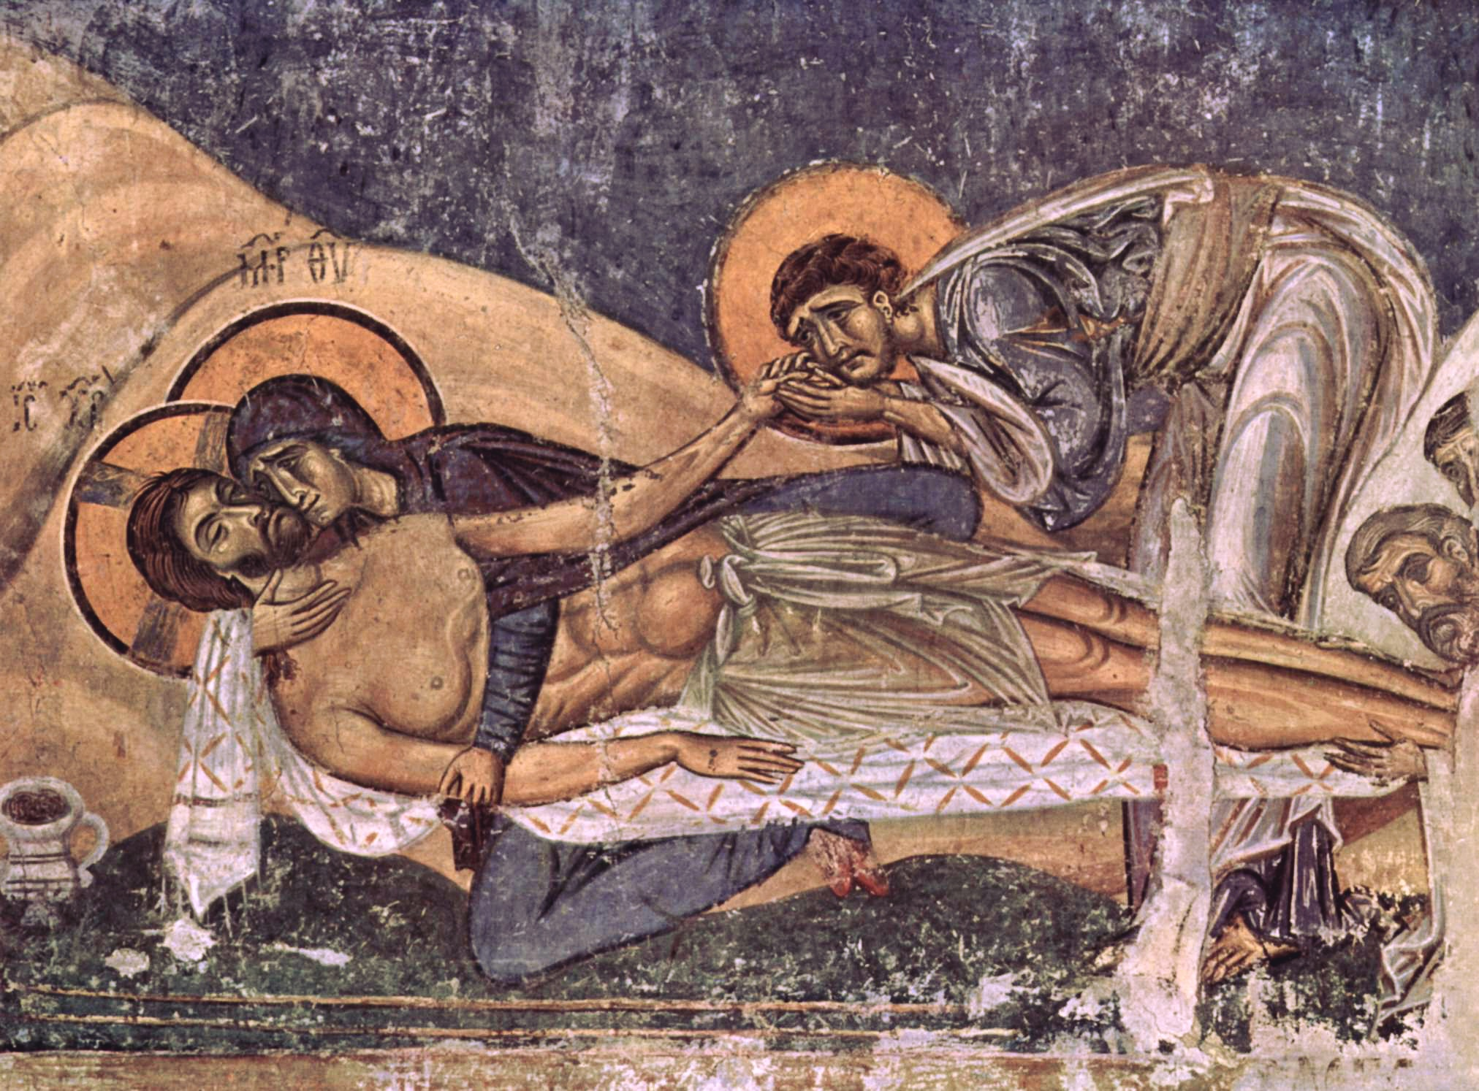

Questions to Consider
1.

Read this online at https://open.byu.edu/new/lamentation

