# Chapter 16: Realism

Portions of the following text are taken from smarthistory.org, which is available for use under CC BY-NC-SA. Please see the citations at the bottom of the page for more information. The text has been adapted to more closely adhere to Chicago Manual of Style and Ensign College Style Guide.

The Royal Academy supported the age-old belief that art should be instructive, morally uplifting, refined, inspired by the classical tradition, a good reflection of the national culture, and, above all, about beauty. But trying to keep young 19th-century artists’ eyes on the past became an issue! The world was changing rapidly, and some artists wanted their work to be about their contemporary environment—about themselves and their own perceptions of life. In short, they believed that the modern era deserved to have modern art.

The modern era begins with the Industrial Revolution in the late 18th century. Clothing, food, heat, light, and sanitation are a few of the basic areas that modernized the 19th century. Transportation was faster, getting things done got easier, shopping in the new department stores became an adventure, and people developed a sense of leisure time—thus the entertainment businesses grew.

In Paris, the city was transformed from a medieval warren of streets to a grand urban center with wide boulevards, parks, shopping districts, and multi-class dwellings (so that the division of class might be from floor to floor—the rich on the lower floors and the poor on the upper floors in one building—instead of by neighborhood). Therefore, modern life was about social mixing, social mobility, frequent journeys from the city to the country and back, and a generally faster pace, which has accelerated ever since.

How could paintings and sculptures about classical gods and biblical stories relate to a population enchanted with this progress?

In the middle of the 19th century, the young artists decided that it couldn’t and shouldn’t. In 1863, the poet and art critic Charles Baudelaire published an essay entitled “The Painter of Modern Life,” which declared that the artists must be of their own time.

Gustave Courbet, a young fellow from the Franche-Comté, a province outside of Paris, came to the big city with a large ego and a sense of mission. He met Baudelaire and other progressive thinkers within the first years of making Paris his home. Then, he set himself up as the leader of a new art: Realism—“history painting” about real life. He believed that if he could not see something, he should not paint it. He also decided that his art should have a social consciousness that would awaken the self-involved Parisian to contemporary concerns: the good, the bad, and the ugly.

**Video Transcript**

#### Early Photography

Photography was developed in the 1820s. The earliest photographic methods required hours, if not days, of exposure time. The daguerreotype, introduced by Louis Daguerre in 1839, became the first commercially successful photographic process, as it reduced exposure times significantly. Photography did not achieve mainstream acceptance as an art form until the 1940s; prior to this point, it was considered a mechanized, scientific process devoid of the artistic soul and human touch associated with traditional artistic methods. Cartoons like Daumier’s Nadar, élevant la Photographie à la hauteur de l'Art poked fun at the thought of photography rising into the realm of high art. Although photography did not achieve widespread acceptance as an art form until the 20th century, early pioneers, including the French photographer Nadar and English photographer Julia Margaret Cameron championed the process and explored its artistic qualities.

#### Realism

Realism, as the name suggests, was a movement dedicated to depicting the sights and scenes of everyday life in a realistic manner, answering the call of Baudelaire and other art critics and intellectuals for the painting of modern life. It represents a rejection of the classical tradition and idealization in favor of truth and sincerity, modern subject matter, and depicting life as it was regardless of what contemporary audiences wanted to see.

#### Pre-Raphaelite Brotherhood

The Pre-Raphaelite Brotherhood was formed in 1848 as a secret society by a group of young artists disillusioned by the art promoted by the British Royal Academy. The group exhibited their paintings anonymously under the initials PRB and modeled their art on the paintings of the early Renaissance painters prior to Raphael. They placed a particular focus on simplicity and an extreme attention to detail and were particularly drawn to subjects taken from literature, poetry, religious topics, and medieval romances. Although they began as a renegade group, the Pre-Raphaelites went on to gain the favor of John Ruskin, the predominant Victorian art critic, and the movement gained more influence and widespread support. The Brotherhood only lasted about five years before disbanding in 1853.

If we look closely at Courbet’s painting

The

Stonebreakers

from 1849 (painted only one year after Karl Marx and Friedrich Engels wrote their influential pamphlet,

The Communist Manifesto

), the artist’s concern for the plight of the poor is evident. Here, two figures labor to break and remove stone from a road that is being built. In our age of powerful jackhammers and bulldozers, such work is reserved as punishment for chain gangs.

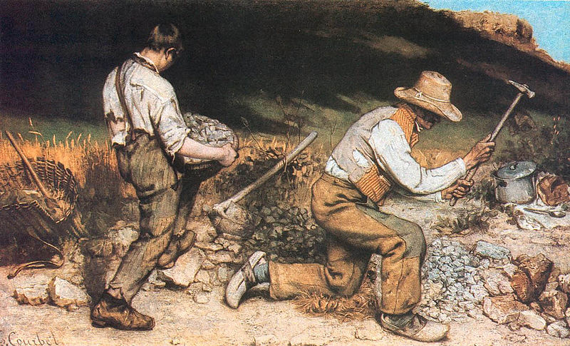

Unlike Millet, who, in paintings like The Gleaners, was known for depicting hard-working but idealized peasants, Courbet depicts figures who wear ripped and tattered clothing. And unlike the aerial perspective Millet used in The Gleaners to bring our eye deep into the French countryside during the harvest, the two stone breakers in Courbet’s painting are set against a low hill of the sort common in the rural French town of Ornans, where the artist had been raised and continued to spend a much of his time. The hill reaches to the top of the canvas everywhere but the upper right corner, where a tiny patch of bright blue sky appears. The effect is to isolate these laborers, and to suggest that they are physically and economically trapped. In Millet’s painting, the gleaners’ rounded backs echo one another, creating a composition that feels unified, whereas Courbet’s figures seem disjointed. Millet’s painting, for all its sympathy for these poor figures, could still be read as “art” by viewers at an exhibition in Paris.

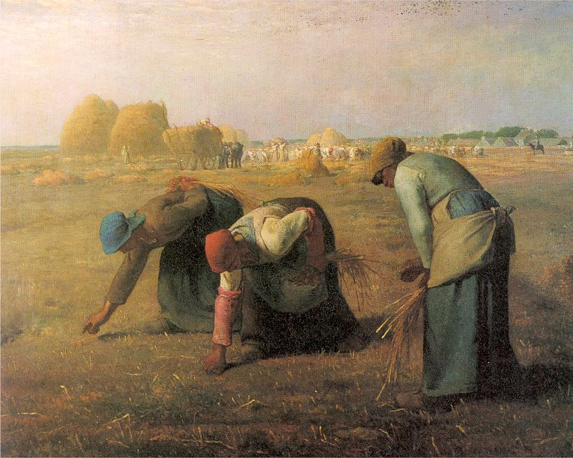

Courbet wants to show what is real, and so he has depicted a man who seems too old and a boy who seems still too young for such back-breaking labor. This is not meant to be heroic: it is meant to be an accurate account of the abuse and deprivation that was a common feature of mid-century French rural life. As with so many great works of art, there is a close affiliation between the narrative and the formal choices made by the painter, meaning elements such as brushwork, composition, line, and color.

Like the stones themselves, Courbet’s brushwork is rough—more so than might be expected during the mid-19th century. This suggests that the way the artist painted his canvas was in part a conscious rejection of the highly polished, refined Neoclassicist style that still dominated French art in 1848.

Perhaps the most characteristic of Courbet’s style is his refusal to focus on the parts of the image that would usually receive the most attention. Traditionally, an artist would spend the most time on the hands, faces, and foregrounds. Not Courbet. If you look carefully, you will notice that he attempts to be even-handed, attending to faces and rocks equally. In these ways, The Stonebreakers seems to lack the basics of art (things like a composition that selects and organizes aerial perspective and finish) and as a result, it feels more “real.”

Read this online at <https://open.byu.edu/history_of_the_fine_arts_music/realism>