Chapter 14: Rococo and Neoclassical Art
Portions of the following text are taken from smarthistory.org, which is available for use under CC BY-NC-SA. Please see the citations at the bottom of the page for more information. The text has been adapted to more closely adhere to Chicago Manual of Style and Ensign College Style Guide.
Rococo art grew out of a reaction to the formal grandeur and heaviness of the baroque style. Established in Paris in 1720, the rococo style was light and whimsy, characterized by soft colors, delicate forms, curving lines, and themes of nature, playfulness, youth, and love. The term rococo was derived from the word rocaille, which means pebble or rock, referring to the ornamental stones and shells used to decorate the fountains of a grotto. The rococo era is attributed to King Louis XV, who was considered a “perpetual adolescent,” and his mistress Madame de Pompadour, the style authority of France and patron of the movement.
Neoclassical art, on the other hand, was a revolt against the opulence and gaudy styles of the baroque and rococo periods that parallels the political revolts that led to the French Revolution. In an effort to supply a newly invented culture and society with the history and mythology it needed, art students and aristocracy of this period took a Grand Tour to visit recently unearthed ruins and artifacts in Greece and Italy, leading to a revitalization of classical thought. Artists sought to express ideal virtues, teach moral lessons, and improve (or reinvent) society. Characteristics of Neoclassical art included clarity of form, sober colors, shallow space, and timeless classical subjects. Neoclassical artists and architects merged their work with past Greco-Roman ideals, ideas that mirrored what was going on in the social environment of the time, leading up to the French Revolution.
Video Transcript

Rococo
After the death of Louis XIV, monarchial power in France began to decline. The rococo style was born as many of the aristocracy left Versailles and established their own homes in Paris. The rococo style exhibits the richness of the baroque but on a smaller, more intimate scale. An emphasis is placed on the use of delicate, organic and graceful detailing, a love of illusionism (seen in the use of mirrors and blurring of architectural lines), with inspiration often drawn from asymmetrical forms found in nature. Rococo painting is characterized by the use of light, pastel colors, soft, feathery brushwork, lush and fanciful depictions of nature, and the portrayal of escapist subjects such as leisure and romance.

Neoclassical Art
Neoclassicism means “new classicism”, and refers to the revival of the classical style, architecture, and subject matter that began in the 1720s and drew inspiration from the excavation of the ancient Roman cities of Pompeii and Herculaneum. This revival of classicism was different from those that came before, as there was a demand for archaeological exactness and accuracy in its reproduction of the classical style. The neoclassical movement began as a reaction against the frivolity of the rococo, which had come to be associated with the excesses and extravagance of the aristocracy. It represented a return to subject matter perceived to be moral, logical, and inspiring, celebrated the noble actions of classical statesmen and military leaders, and promoted devotion to family, country, and personal sacrifice for the greater good. The classical style carried a political charge in 18th-century Europe, as it was associated with the democratic and republican governments of ancient Greece and Rome. As a result, the style was used in the art and pageantry of the French Revolution.

Rococo
In the early years of the 1700s, at the end of the reign of Louis XIV (who died in 1715), there was a shift away from the classicism and “Grand Manner” that had governed the art of the preceding 50 years in France, toward a new style that we call rococo. The Palace of Versailles, in its show of decadence and monarchical disconnectedness, was abandoned by the aristocracy, who once again took up residence in Paris. Similarly, the art of this period suggests a similar shift away from the monarchy toward the aristocracy.
The aristocracy had enormous political power as well as enormous wealth, passed from generation to generation. Many chose leisure as a pursuit and became involved in romantic intrigues. Indeed, they created a culture of luxury and excess that starkly contrasted the lives of most people in France. The aristocracy—only a small percentage of the population of France—owned over 90 percent of its wealth. The small, but growing in number and influence, middle class grew quickly intolerant of such displays.

The Swing, Fragonard
As with most rococo paintings, the subject of Jean-Honoré Fragonard’s The Swing is not very complicated. Inside a lush garden, a young woman in a billowing pink gown glides through the air. Her suspension high above the ground is enabled by a swing consisting of a crimson velvet cushioned seat and a pair of ropes tied around the knobby branches of an enormous tree. On the far right, an older man seated on a stone bench helps operate the device. Using a series of connected ropes, he pulls the swing back to create the momentum necessary to propel the woman forward. As he releases the ropes, she leans back and extends her legs, expelling a tiny pink slipper from her pointed foot. The dainty shoe flies through the air toward a marble statue on the far left. At the base of the large pedestal supporting this sculpture lies a young man. Partially hidden by an overgrown rose bush, he peers wide-eyed up the open skirt of the swinging woman.
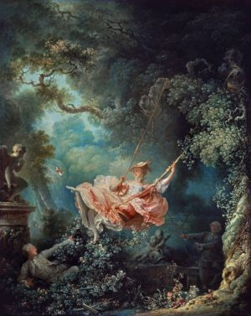
This work was reportedly a commission; a gentleman of the court requested the painter represent his mistress being pushed on a swing as he secretly admired her from below. While the figures in the work are not identifiable as portraits of specific individuals, their rich attire and leisurely activity underline their aristocratic status. Such playful and erotic scenes were popular among the elite clientele Fragonard served. Unlike large-scale history paintings or the widely collected genres of portraiture and landscape, these works were relatively small (81 x 64.2 cm in the case of The Swing) and intended for display in intimate rooms known as cabinets. Admiring the painting in the privacy of such a space, the patron and his inner circle would have appreciated its depiction of societal norms subverted for the pursuit of personal pleasure. The work’s strong appeal led to the production of a printed version by Nicolas Delaunay in 1782, which circulated among a broader, though still elite, audience of collectors.
If you look closely, you can see the loose brushstrokes in the pink silk dress—and as she opens her legs, we get a glimpse of her stockings and garter belt. It was precisely this kind of painting that the philosophers of the Enlightenment were soon to condemn. They demanded a new style of art, one that showed an example of moral behavior, of human beings at their most noble.

Questions to Consider
- One of the key elements of the rococo is the disconnect between the subjects and situations that paintings in this style depict and the social and economic realities of the times. How might this work have been received by a working-class audience? How might it have been received by an aristocratic one? What message does it send?
- Who was the intended viewer of this work? How does that change your understanding of its content?

Neoclassical
In opposition to the frivolous sensuality of rococo painters like Jean-Honoré Fragonard and François Boucher, the Neoclassicists looked back to the French painter Nicolas Poussin for their inspiration (Poussin’s work exemplifies the interest in classicism in French art of the 17th century). The decision to promote “Poussiniste” painting became an ethical consideration—they believed that strong drawing was rational and, therefore, morally better. They believed that art should be cerebral, not sensual.
France was on the brink of its first revolution in 1789, and the Neoclassicists wanted to express rationality and seriousness fitting for their times. Artists like David supported the rebels through art that asked for clear-headed thinking, self-sacrifice to the State, and an austerity reminiscent of Republican Rome. Neoclassicism was a child of the Age of Reason (the Enlightenment) when philosophers believed that we could control our destinies by learning from and following the laws of nature (the United States was founded on Enlightenment philosophy). Scientific inquiry attracted more attention. Therefore, neoclassicism continued the connection to the classical tradition because it signified moderation and rational thinking but in a new and more politically charged spirit.
The neoclassicists, such as Jacques-Louis David (pronounced Da-VEED), preferred the well-delineated form—clear drawing and modeling (shading). Drawing was considered more important than painting. The Neoclassical surface had to look perfectly smooth—no evidence of brush strokes should be discernible to the naked eye. Neoclassicism is characterized by clarity of form, sober colors, shallow space, and strong horizontals and verticals that render that subject matter timeless (instead of temporal as in the dynamic baroque works), and classical subject matter (or classicizing contemporary subject matter).

Cornelia Points to Her Children as Her Treasures, Kauffman
To the artists of 18th-century Europe, it was not enough to simply paint a beautiful painting. Yes, one could marvel at your use of colors and proportions and how masterfully you draped the fabric on your figures, but this was just not enough. The story that is represented must also improve the viewer and impart a moralizing message. This was a common theme even before the emergence of the Neoclassical trend. When interest in the ancient cultures of the Mediterranean—more specifically Rome—arose in the mid-18th century, the moralizing theme segued to also include stories from classical antiquity.
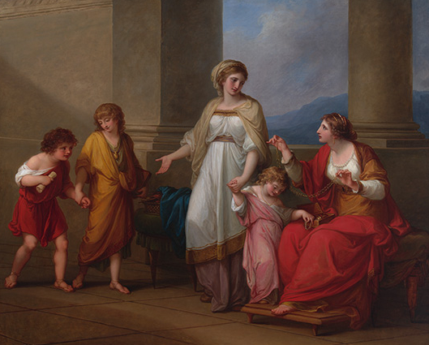
The Swiss-born painter Angelica Kauffmann is just one artist to contribute to this genre. Painted in 1785, Cornelia, Mother of the Gracchi, Pointing to Her Children as Her Treasures, is her subject. Roman architectural influences frame two women portrayed wearing what one can imagine is typical of ancient Roman dress, along with three children, also wearing masterfully draped togas with thin leather sandals. They look like they might have stepped directly off a temple’s pediment.
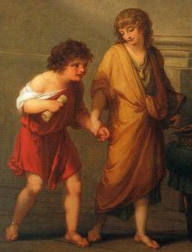
Born in 1740, Angelica Kauffmann received a first-rate artistic education from her father, who was a Swiss muralist. She traveled through her native Switzerland, Austria, and eventually Italy, where she was able to see the work of the ancient artists with her own eyes. She was following in the tradition of the Grand Tour, the educational excursion that many wealthy Europeans took to marvel at and study the art, architecture, and history of ancient Rome.
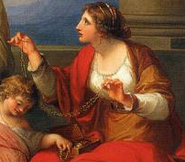

Tier 2: Context—Cornelia Points to Her Children as Her Treasures
Like all artwork, the context of this work helps us know how to understand the work in its own time. As you consider this work, refer to the elements of art listed in Tier 2: Context.
Kauffman's painting of Cornelia with her children is an excellent example of how social implications affect the style and content of a work. If you compare Kauffmann’s simple presentation to the previous rococo genre, with the lush landscapes, frothy pastel pink frocks, and chubby frolicking cherubs, it is clear that art is going in a different direction. This painting is an exemplum virtutis, or a model of virtue. The story that Kauffmann painted is that of Cornelia, an ancient Roman woman who was the mother of the future political leaders Tiberius and Gaius Gracchus. The brothers Gracchi were politicians in second-century BCE Rome. They sought social reform and were seen as friends to the average Roman citizen. So where did these benefactors of the people learn their exemplary ethics? That would be their mother, Cornelia.
The scene we see in Kauffmann’s painting illustrates one such example of Cornelia’s teachings. A visitor has come to her home to show off a wonderful array of jewelry and precious gems, what one might call treasures. To her visitor’s chagrin, when she asks Cornelia to reveal her treasures, she humbly brings her children forward instead of running to get her own jewelry box. The message is clear; the most precious treasures of any woman are not material possessions, but the children who are our future. You can almost feel the embarrassment when you look at the face of the visitor, who Kauffmann has smartly painted with a furrowed brow and slightly gaped mouth.
The interest in ancient Mediterranean cultures was fueled not just by the cultural productions of Rome, but also by the newly discovered remains of the ancient Roman cities of Herculaneum and Pompeii, which were excavated beginning in 1738 and 1748, respectively. Covered by the volcanic ash of Mount Vesuvius in August 79 CE, an almost perfect scene of typical ancient life was preserved. These findings did not just spark a renewed interest in classical antiquity in 18th-century art and architecture but also inspired new fashions, interior design, and even gardens and tableware. This was a find that one must see in person, and Angelica Kauffman was lucky enough to take the Grand Tour like so many of her fellow artists.
While the geometric symmetry and simplicity of the arts in antiquity might have greatly inspired the work of Kauffman and other neoclassical artists, these ancient societies also aligned with Enlightenment ideals, which were often seen as the zenith of human civilization. Greece and Rome—it was felt—were the cultures that gave us the enlightened political systems of democracy and republicanism, as opposed to the modern monarchies, which would be increasingly criticized as corrupt and arbitrary in the mid- and late-18th century. The ancients could instruct modern audiences in patriotism, civic virtue, and ethics, and Kauffmann’s moralizing message is a wonderful example of this trend.
This revival of classical antiquity was a cultural phenomenon that affected not just artistic practices, but also shaped the modern mind. Angelica Kauffman would eventually settle in England, where she enjoyed great success as a portrait artist and history painter. In an age that can be described as patriarchal at its best and chauvinistic at its worst, Kauffmann played a major role in the British art scene. She was a regular exhibitor at the prestigious Royal Academy and had many aristocratic and even royal patrons. Cornelia Pointing to Her Children as Her Treasures is truly one of Kauffmann’s most famous treasures, and permanently positioned her as a pioneer of the neoclassical movement.

The Death of Marat, David
By 1793, the violence of the Revolution dramatically increased until the beheadings at the Place de la Concorde in Paris became a constant, leading a certain Dr. Joseph Guillotine to invent a machine that would improve the efficiency of the ax and block and, therefore, make executions more humane. David was in the thick of it. Early in the Revolution, he had joined the Jacobins, a political club that would, in time, become the most rabid of the various rebel factions. Led by the ill-fated Georges Danton and the infamous Maximilien Robespierre, the Jacobins (including David) would eventually vote to execute Louis XVI and his queen, Marie Antoinette, who were caught attempting to escape across the border to the Austrian Empire.
At the height of the Reign of Terror in 1793, David painted a memorial to his great friend, the murdered publisher, Jean Marat. As in his Death of Socrates, David substitutes the iconography (symbolic forms) of Christian art for more contemporary issues. In Death of Marat, 1793, an idealized image of David’s slain friend, Marat, is shown holding his murderess’s (Charlotte Corday) letter of introduction.
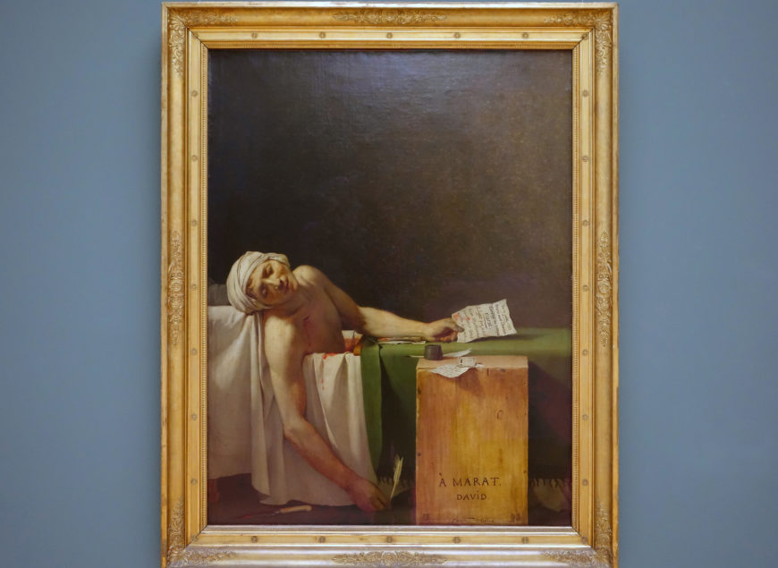
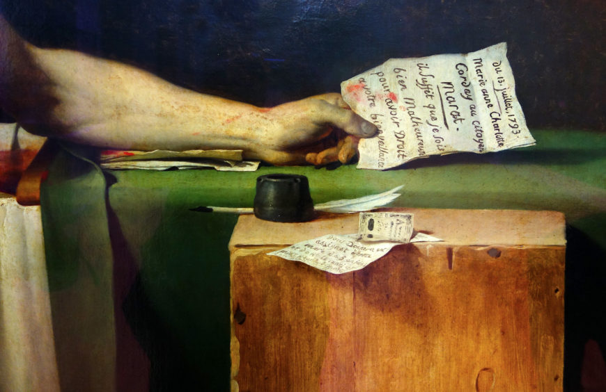
The bloodied knife lays on the floor, having opened a fatal gash that functions, as does the painting’s very composition, as a reference to the entombment of Christ and a sort of secularized stigmata (a reference to the wounds Christ is said to have received in his hands, feet, and side while on the cross). Is David attempting now to find revolutionary martyrs to replace the saints of Catholicism (which had been outlawed)?
By 1794 the Reign of Terror had run its course. The Jacobins had begun to execute not only captured aristocrats but fellow revolutionaries as well. Eventually, Robespierre himself would die and the remaining Jacobins were likewise executed or imprisoned. David escaped death by renouncing his activities and was locked in a cell in the former palace, the Louvre, until his eventual release by France’s brilliant new ruler, Napoleon Bonaparte. This diminutive Corsican had been the youngest general in the French army and, during the Revolution, had become a national hero by waging a seemingly endless string of victorious military campaigns against the Austrians in Belgium and Italy. Eventually, Napoleon would control most of Europe, crown himself emperor, and release David in recognition that the artist’s talent could serve the ruler’s purposes.
Video Transcript

We're in Brussels, looking at one of Jacques-Louis David's Revolutionary canvases. This is The Death of Marat.
Revolutionary in two senses: revolutionary in that it was painted during the French Revolution, which started in 1789. France was made a republic in 1792. And David here commemorates a hero of the Revolution. But it's also revolutionary in that it's depicting a contemporary event. Before this, David had painted scenes from classical antiquity.
Early on in the Revolution, David had joined the Jacobin Club. This was a group of the most violent and radical revolutionaries. And David himself became quite close with the leader of the Jacobins, Robespierre.
David voted for the beheading of King Louis XVI. His signature is on documents created for the arrest and execution of members of the aristocracy, of people who were against the Revolution. So David was really in the thick of it. He served in the Revolutionary government. He helped to dissolve the Royal Academy of the Arts, and he was essentially the Minister of Propaganda, spreading the ideals of the Revolution through images.
And that's what this is. The Revolutionary government asked him to produce a series of three images that would heroicize new martyrs. Not a Christian martyr, but now a martyr to the Revolution. This shift from Christian martyr to political martyr is an important one. We have the beginnings of the end of the world of the monarchy, of the ancien régime, of an absolutist ruler, and the beginnings of a new republic. The beginnings of a world where the people participate in the government.
The French Revolution had been inspired, at least in part, by the American Revolution just a few years earlier. But France would oscillate between republican and royalist governments over the next century. A royalist named Charlotte Corday, a woman who believed in the monarchy of absolutist rule, went to see Marat, this leader of the Revolution. And by tricking him, murdered him in his bathtub.
You can see the knife, which she used to stab him, lying on the bottom left corner of the canvas. And the letter that she used to gain entrance being held by Marat. He was a publisher, so his role in the Revolution was important, because he helped to disseminate revolutionary ideas and to rally the people.
He holds this letter that she used to get in to see him. David is showing, look at how duplicitous this woman was. She tricked Marat. He was innocent. He was good. He was working for the republic, for the French Revolution. And she came in and brutally stabbed him.
There is this extreme contrast between her duplicity and his nobility. He's ideally beautiful. We know that he was disfigured by the skin disease that caused him to spend many hours of each day in the bath. You have no sign of that here.
And his pose reminds us of the Pietà, of the image of Christ being mourned having just been taken down from the cross. So the idea that a martyr to the Revolution is replacing the central Christian martyr is vividly rendered.
That was a key idea of the Revolution. To dismantle not only the monarchy, but the church as well. And to secularize French life. And we see that also in the creation of a new calendar for the Revolution. And below the signature, David has written "Year Two." So we're not in 1793, we're in Year Two of the Revolution. This whole replacing of the old world with a new Revolutionary order for a new French republic. The idea of rationalism was being violently instituted. Instead of the older, traditional measurements, for example, this is when we first have the more rational metric system being introduced.
This is the Enlightenment. This is a time of rational thinking, of believing in empirical observation over the superstitions and traditions of the church. And this is a painting that is all about observations. This really interesting contrast between the specificity of the foreground, especially the crate on which he's written his name, and written "Á Marat," "To Marat." Against the indeterminate, open brushwork of the background that almost doesn't look finished, it's got this soft, feathery, warm quality. It isolates Marat. It focuses our attention on him. But as we look around at other paintings in this museum, what I see in the upper part of a painting are angels. And David can't have that anymore. And a new iconography has not yet developed. So instead, what we have is a lighter field in the upper right corner, balancing Marat's body in the lower left corner.
And what a body. The anatomy, the muscles in the shoulder and the arms and the collarbone. We can see that neoclassical interest in studying the anatomy, painting it very carefully, paying a lot of attention to contours, modeling in the effects of light and dark. But what strikes me is the spareness. In direct contrast to the luxurious interiors of rococo paintings of the lifestyle of the aristocracy, which was the subject of rococo paintings. Here, a decidedly stark interior, Spartan, no elaborate furniture, no gold. This is a man, David wants to tell us, lived according to the republican ideals of the Revolution.
And it looks like they will endure forever. But soon the Revolutionaries will turn against each other.
And David is imprisoned for his involvement in the Revolution. And then becomes First Painter to Napoleon, who becomes the Emperor of France. And so a lot of art historians look at David's career and say, "Where were his actual principles?"
Where were his loyalties?
Did he truly believe in the ideals of the Revolution? And then become a follower of Napoleon and abandon those values? Or was he politically mercenary? Was he really looking for commissions from whoever was in control at that moment? It's hard to look at The Death of Marat and not see a man who was convinced of the importance of Revolutionary ideals.

Questions to Consider
- How does this work reflect the general desire to re-invent society during the French Revolution?
- In what ways does this work recall classical models, styles, or subjects?

Read this online at https://open.byu.edu/history_of_the_fine_arts_music/rococo_and_neoclassical_art

