# Unit 3: The Renaissance

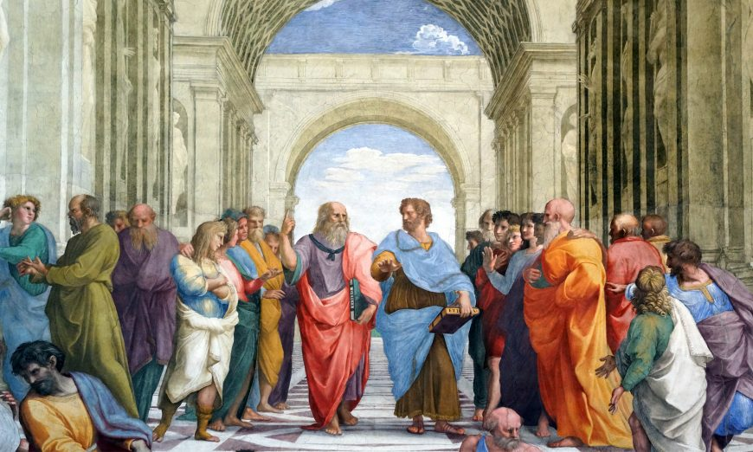

## Italian Renaissance Art

Even if you are not a student of art history, you are likely familiar with the names Donatello, Leonardo, Raphael, and Michelangelo. There is a reason these names continue to be part of our contemporary popular culture (and it’s not just because these are the names of everyone’s favorite martial arts Mutant Turtles). These artists were central to what we today call the Renaissance—a period in European history (ca. 1400–1600) when some of our current ideas about society, politics, and art took form.

As the Eastern half of the Roman Empire (the Byzantine Empire) grew weaker against invading forces (it would finally fall in 1453 CE), scholars, artisans, and other cultural or political figures fled to the West, arriving at a collection of eastern port towns such as Venice. These groups of people brought with them knowledge, skills, documents, and history that had been long forgotten in the West, ushering in a fervor for the rediscovery of ancient cultures. The term “Renaissance” is often used to designate a rebirth of interest in the ancient Greek and Roman worlds (often referred to as “classical antiquity”) that arose in Europe during the later Middle Ages.

While engagement with the Greco-Roman past was not new, it took on a new urgency in Italy beginning in the 14th century and was eventually felt throughout the European continent. This interest prompted new intellectual investigations (such as humanism) that had a profound influence on European culture, affecting all realms of life, including the visual arts.

Many of the artistic traditions originating or maturing in this context informed the direction of European art for the next several centuries. Linear perspective, volumetric figures rendered with anatomical precision, emotionally charged expression, and visual naturalism are formal elements popularized in the Renaissance. This was especially true of art in Italy where ancient Roman art demonstrating many of these traits was abundant (such as Roman relief sculpture and architecture).

This was also the period when artistic theory and the European discipline of art history began to develop. Leon Battista Alberti’s treatise, On Painting (1435/36), was the first theoretical text written on visual art in Europe, and Giorgio Vasari’s Lives of the Most Excellent Painters, Sculptors, and Architects (1550, 2nd edition 1568) was the first critical history of European art. Many of the ideas originating in the writings of these men and their contemporaries are still fundamental to artistic theory and practice today. In fact, Vasari’s categories of artists, including his privileging of Florentines and standards for evaluation of their work, have dominated the discipline. For several centuries after his text’s publication, the artists and visual approaches that he celebrated were seen as the gold standard in art, the foundation for what we call the European canon.

## Tier 2—Context

To understand the art of the Italian Renaissance, we need to consider the values, social mores, and religious and political interests of the people who made, paid for, and first looked at the art. Unfortunately, our knowledge of these people is limited and skewed. History is most often written by those in positions of privilege and power who generally leave behind the most evidence of their lives and ideas. This means that we have quite a bit of information about some people—primarily Christian men who were wealthy merchants, educated elites, or members of the Church—and little to none from other social groups, including most women, the peasantry, non-Christians, and non-Europeans. Understanding the various contexts of a work helps us to draw different conclusions about the artwork itself. For example, Raphael’s serene and pensive sitter (below) is a far cry from the reality of the man depicted: the fiery Warrior Pope, Julius II. Even Raphael, the artistic darling of early 16th-century Rome, was far removed from his powerful patron’s exalted status.

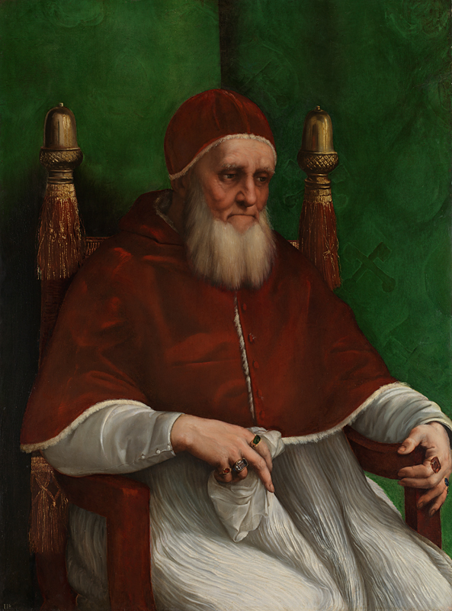

### Artists and Artisans

With few exceptions, artists did not enjoy the status of intellectuals or social elites. Because they made things by hand that they then sold for profit, they were deemed of lower social stature than the wealthy merchants and aristocrats who bought their work. Art making was traditionally seen as a mechanical, and not a liberal art (art of the mind). While the status of the artist did improve over the course of the Renaissance—thanks in part to our Ninja Turtles’ namesakes—it was a slow and uneven process. Most artists came from what we might call urban, middle-class roots and trained for a long period in a workshop, learning their craft rather than receiving the kind of liberal arts education available to members of the upper classes. Even though art theorists like Leon Battista Alberti argued for an artist’s education in a range of subjects, including philosophy (which included “natural philosophy” or science), poetry, mathematics, medicine, and geometry (to name just a few), access to this education was limited. This changed somewhat in the 16th century with the rise of the first art academies, although the extent to which an artist could receive the kind of extensive education deemed ideal was still limited. Such advanced training was reserved for the sons of the elite. Even Leonardo da Vinci, the so-called universal genius (perhaps one of the few figures in history to whom that problematic title may justly be applied), was outside the world of highest learning, never having mastered Latin.

Despite the challenges facing Italian artists in participating directly in Renaissance intellectual culture, many fought vigorously to elevate the status of their profession and their own corresponding social standing. Some artists, like Leonardo, sought to elevate visual art by drawing comparisons to philosophy or poetry. As he noted, "Painting is mute poetry and poetry is blind painting."

They argued that despite making objects by hand, the Renaissance artist’s practice was guided first by the intellect—like a poet or a philosopher. Such arguments were modeled on the writings of ancient Roman authors like Pliny, Lucian, and Cicero, another example of humanism at work.

As humanist-inspired tastes in art developed over the course of the early Renaissance, so too did requirements for artists’ skills. Art-making became increasingly professionalized. To develop the mathematically defined spaces populated by anatomically correct figures enacting complex narrative scenes from religious and classical history that were in vogue, artists needed to study geometry and anatomy. They had to read ancient texts in translation and consult with learned advisors, develop sophisticated preparatory studies, and negotiate business contracts. They also needed to navigate complex social relationships requiring savvy interpersonal skills.

As in most occupations at the time, it was not only social class, but also gender that determined artistic identity: artists were almost entirely men, and art-making was thought to be a male prerogative. The professionalization of artistic practice that helped raise the social status of art-making had the negative effect of excluding women who, particularly in mercantile cities like Florence, were increasingly regulated to the domestic sphere. Although some female artists did achieve renown (such as Sofonisba Anguissola), their numbers were few until well into the 17th century.

You have likely run across the name Michelangelo, but are perhaps less familiar with his great patron, Pope Julius II. This tells us more about our present-day fascination with artists than it does about the realities of the Renaissance past. In this world, the patrons—the people who paid for (commissioned) the artwork—were more socially privileged than the artists who worked for them, and they received much of the credit for the artwork they sponsored. Again, men were the primary patrons, although some women in positions of special privilege, like Isabella d’Este (marchioness of Mantua, a small but glamorous principality in northern Italy), commissioned art as well. There were many reasons for commissioning art. Art could advertise an individual’s learning and taste, wealth, and position, and even political loyalties and religious faith. Patronage ranged across media and genres and was commissioned for a variety of contexts including public piazzas, private homes and palaces, private chapels and tombs in public churches, and other sacred spaces.

### Artworks

I have repeatedly used the word art so far in this chapter. To us, the paintings, sculptures, buildings, tapestries, prints, and other aesthetic objects created during this time are considered “art,” but this was not the case for people living during the Renaissance. The objects and images that we study as Renaissance art were understood to be functional aspects of visual culture. The primary goal was not aesthetic appreciation or art for the sake of art, which is a category of experience that is a 19th-century invention. An altarpiece that may be viewed in an art museum today originally functioned as an object of devotion; it would have been the centerpiece of Christian religious practice in a sacred setting and was first and foremost a didactic tool guiding Christians in their worship. A portrait was a form of commemoration, a way to manifest a sitter’s presence when absent or to communicate family connections. Scenes drawn from ancient poetry or heroic tales were methods of communicating virtue, demonstrating erudition, and encouraging learned discourse. Were these images and objects appreciated as aesthetically interesting, even “beautiful”? Absolutely. But it’s important to note that this was not the primary goal.

In Renaissance art, you will confront two main categories of iconography, or subject matter: secular (non-religious) and religious. Both types fulfilled different functions, but they also sometimes overlapped. Sandro Botticelli’s Birth of Venus, for example, exemplifies secular iconography and borrows from ancient tradition. At the same time, Venus was associated with ideas about divine love circulating in late 15th-century Neoplatonic philosophy, which (among other things) sought to reconcile ancient philosophy with Christianity. We also have two main categories of audience: public and private, which also often overlapped. Donatello’s bronze David was both a private artwork, placed within the powerful Medici family’s palace courtyard, and a public statement of their power, wealth, and faith—the work was visible from the street.

It is also helpful to be conscious of how the present-day media hierarchy is skewed to our own interests. While we tend to prioritize the arts of painting, sculpture, and architecture, what was valued in the past was different from what we emphasize in our current patterns of collection and display. Tapestries, for example, are not often on view in museums in significant numbers, nor are they foregrounded in histories of art, in part because of the fragile nature of their medium (silk and wool thread does not survive the ravages of time as well as marble or brick), but also because the art form went out of style in the modern era. During the Renaissance, however, tapestries were one of the most prized forms of visual art. These spectacular creations were amongst the most sought-after and costly objects, adorning the walls of palaces, churches, and government buildings across Europe. When learning about Renaissance art, you will encounter paintings, large-scale sculptures, and architecture, but it’s important to note that this visual world also included—sometimes more importantly—tapestries, vestments, liturgical objects, small-scale sculptures, prints, ceramics, embroidery, and other works. Our modern interests have shaped what we consider to be “great” art, or what is even considered worthy of study. These biases towards certain media, genres, and artists are our own—or those that we have been taught—not necessarily those of people throughout history, and it is helpful to be conscious of the distorted views of the past that they can sometimes create. Recent scholarship has worked to be more inclusive, increasingly exploring visual production in various media and broadening our definitions of just what constitutes “art.”

Read this online at <https://open.byu.edu/history_of_the_fine_arts_music/the_renaissance>