Chapter 8: Gothic Art

Portions of the following text are taken from smarthistory.org, which is available for use under CC BY-NC-SA. Please see the citations at the bottom of the page for more information. The text has been adapted to more closely adhere to Chicago Manual of Style and Ensign College Style Guide.
Forget the association of the word Gothic with dark, haunted houses or ghostly pale people wearing black nail polish and ripped fishnets. The original Gothic style was actually developed to bring sunshine into people’s lives, and especially into their churches. To get past the accrued definitions of the centuries, it’s best to go back to the very start of the word Gothic, and to the style that bears the name.
The Goths were a so-called barbaric tribe who held power in various regions of Europe between the collapse of the Roman Empire and the establishment of the Holy Roman Empire (so, from roughly the fifth to the eighth century). They were not renowned for their great achievements in architecture. As with many art historical terms, Gothic came to be applied to a certain architectural style after the fact. The style represented giant steps away from the previous, relatively basic building systems that had prevailed. The Gothic grew out of the Romanesque architectural style, when both prosperity and relative peace allowed for several centuries of cultural development and great building schemes. From roughly 1000 to 1400, several significant cathedrals and churches were built, particularly in Britain and France, offering architects and masons a chance to work out evermore complex and daring designs.

Video Transcript
Although the word Gothic often carries connotations of darkness, the Gothic style is centered upon light. Symbolism was interwoven with structural design, with the towering height and light, open interiors referencing the divine—the height drawing the eyes up towards the heavens and colored light (or lux nova as it was referred to) streaming through stained glass windows, representing the glory and presence of God. The use of the Gothic pointed arch channels the weight of a structure more effectively to the structural supports, allowing churches to be built taller, wall space to be opened up for windows, and more interior supports to be removed, creating tall, open, and brighter interiors.

Sainte-Chapelle, Paris
The most fundamental element of the Gothic style of architecture is the pointed arch, which was likely borrowed from Islamic architecture that would have been seen in Spain at this time. The pointed arch relieved some of the thrust and, therefore, the stress on other structural elements. It then became possible to reduce the size of the columns or piers that supported the arch.
So, rather than having massive, drum-like columns as in the Romanesque churches, the new columns could be more slender. This slimness was repeated in the upper levels of the nave so the gallery and clerestory would not seem to overpower the lower arcade. In fact, the column basically continued all the way to the roof and became part of the vault.
In the vault, the pointed arch could be seen in three dimensions where the ribbed vaulting met in the center of the ceiling of each bay. This ribbed vaulting is another distinguishing feature of Gothic architecture. However, it should be noted that prototypes for the pointed arches and ribbed vaulting were seen first in late Romanesque buildings.
The new understanding of architecture and design led to more fantastic examples of vaulting and ornamentation, and the early Gothic or lancet style (from the 12th and 13th centuries) developed into the Decorated or Rayonnant Gothic (roughly 14th century). The ornate stonework that held the windows—called tracery—became more florid, and other stonework even more exuberant.
The ribbed vaulting became more complicated and was crossed with lierne ribs into complex webs, or the addition of cross ribs, called tierceron. As the decoration developed further, the perpendicular or international Gothic took over (fifteenth century). Fan vaulting decorated half-conoid shapes extending from the tops of the columnar ribs.
The slender columns and lighter systems of thrust allowed for larger windows and more light. The windows, tracery, carvings, and ribs make up a dizzying display of decoration that one encounters in a Gothic church. In late Gothic buildings, almost every surface is decorated. Although such a building as a whole is ordered and coherent, the profusion of shapes and patterns can make a sense of order difficult to discern at first glance.

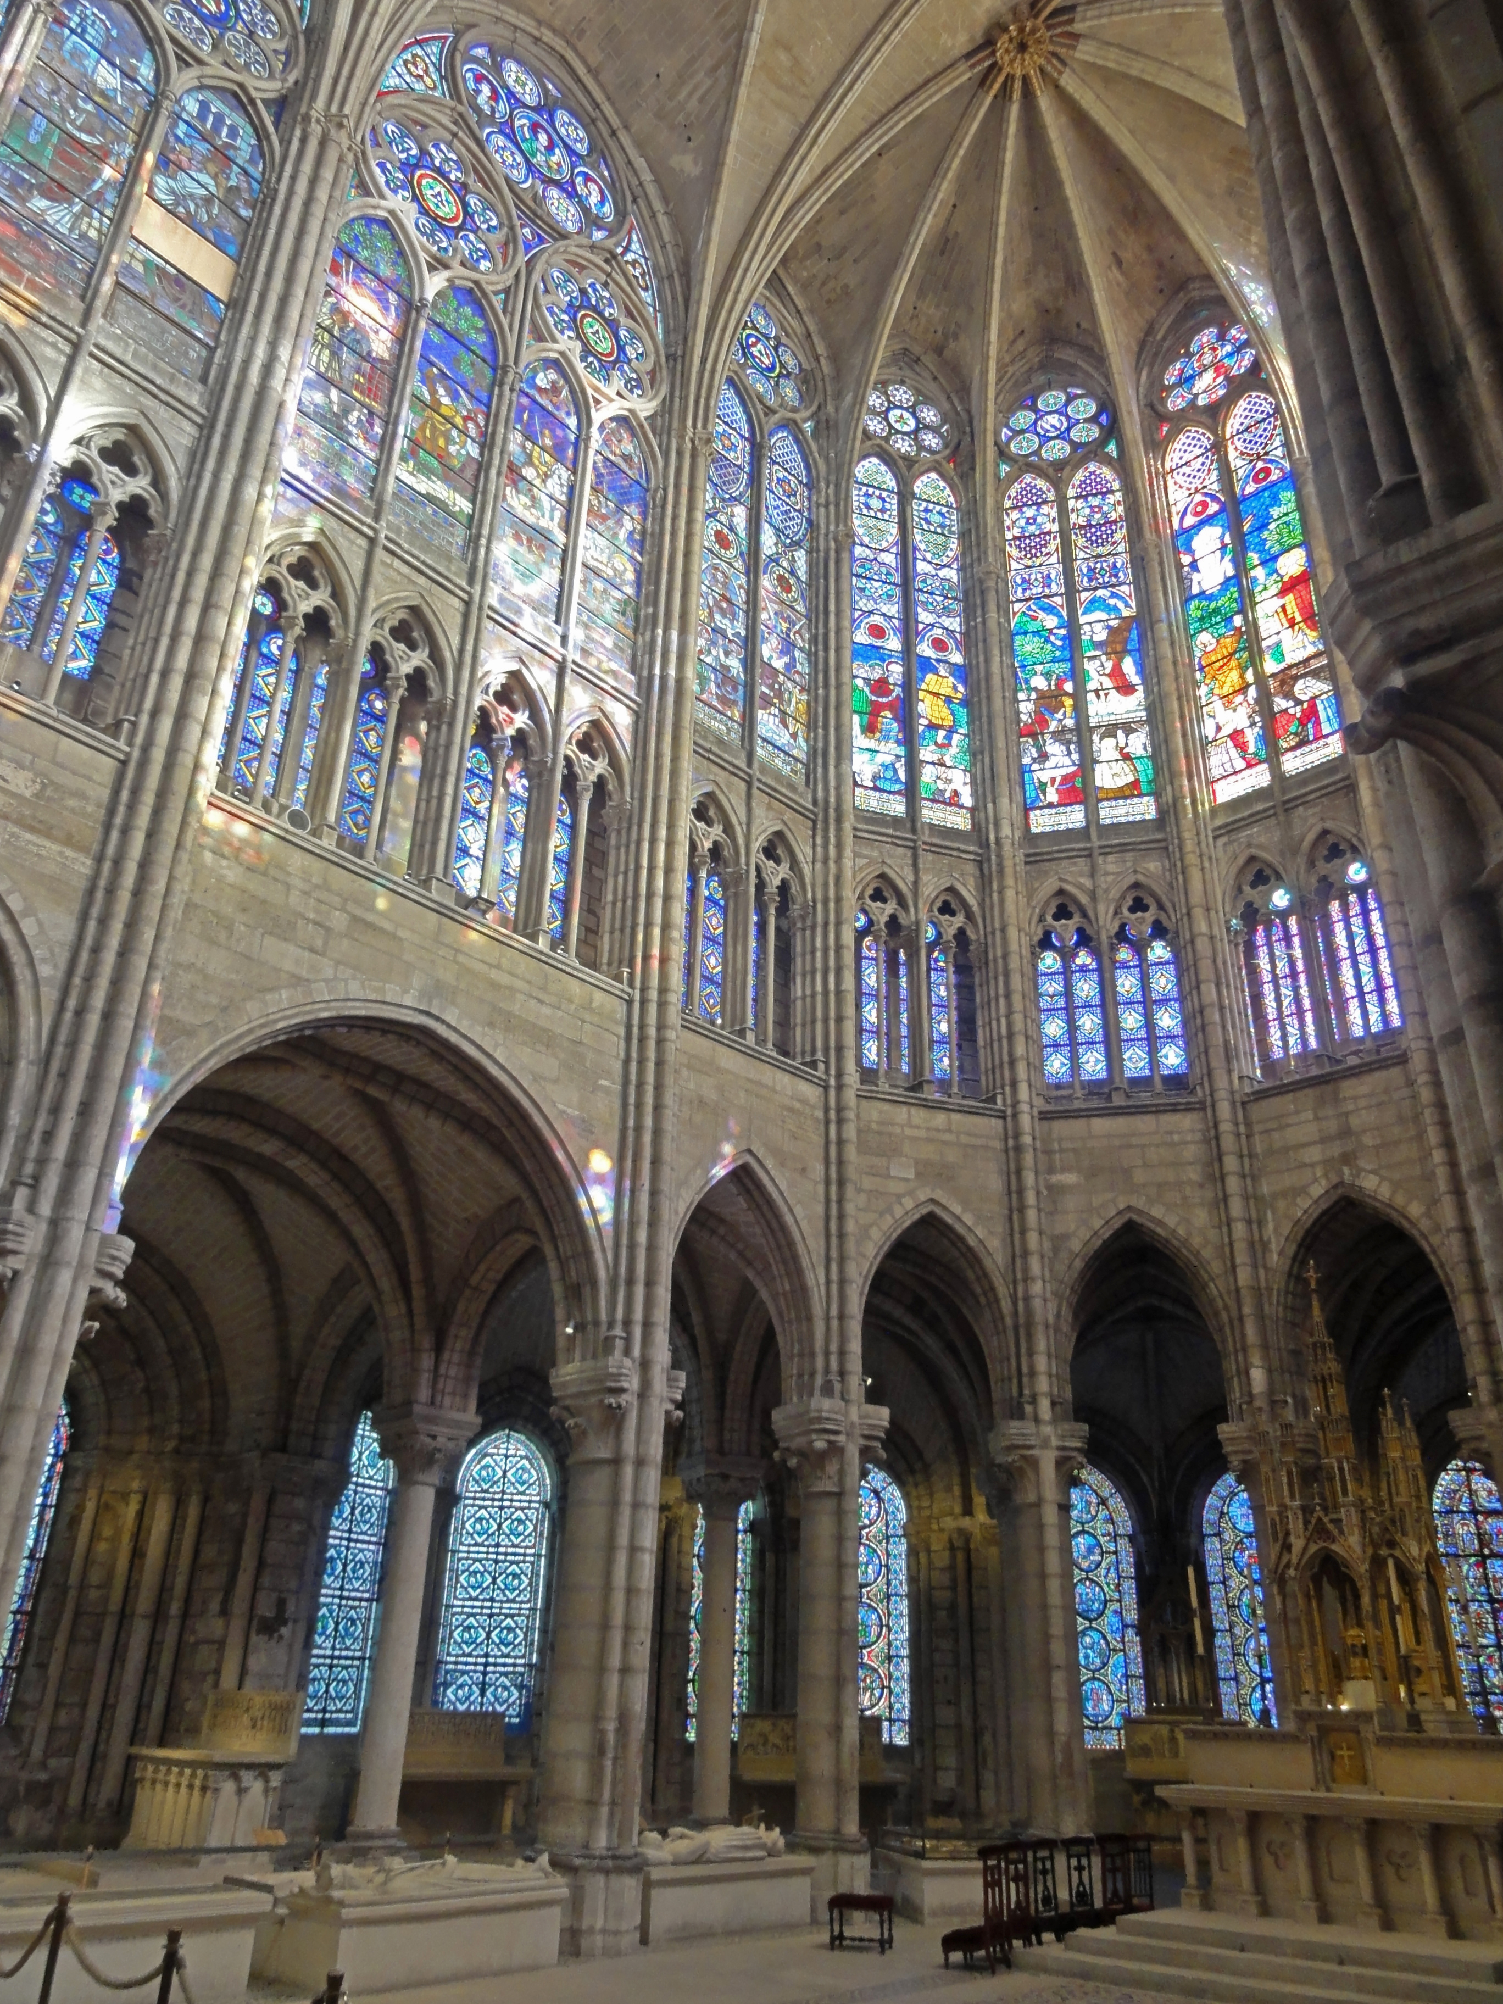
After the great flowering of the Gothic style, tastes again shifted back to the neat, straight lines and rational geometry of the classical era. It was in the Renaissance that the name Gothic came to be applied to this medieval style that seemed vulgar to Renaissance sensibilities. It is still the term we use today, though hopefully without the implied insult, which negates the amazing leaps of imagination and engineering that were required to build such edifices. Let's explore one of these exquisite Gothic buildings.

Questions to Consider
- How does the Gothic style alter the large interior space of Cathedrals?
- Considering the architectural advancements in the Gothic era, how does the role of the church building change in the communities it serves?
Video Transcript
Royal Chapel
We've walked into the courtyard of what had once been the palace of the king of France, and in the center is a jewel box, Sainte-Chapelle.
This was the royal chapel, this was a chapel attached to the royal palace for the use of the king and his household, but it's much more than that.
We walked in through the lower chapel, which was used by the king's household, into the upper channel, which was used by the king, by the queen, and by the court. In fact, there are niches on either side for the king and queen. At the far end was a reliquary and this was the whole point of Sainte-Chapelle.
Relics
The King Saint Louis had obtained one of the great relics of Christendom, the Crown of Thorns. This was part of the passion of Christ. And of course, a crown is symbolic of royalty, and this was the chapel of Saint Louis, also known as King Louis IX. Saint Louis was able to purchase the crown from his cousin, who was the Byzantine emperor.
For an enormous sum.
And I think it's important to just step back and think about what that crown signified. The faithful believe that the crown had touched Christ, had made him bleed. And the idea of the relic is central. It collapses time, it brings Christ into our immediate experience.
Now, relics were incredibly important in medieval culture. They performed miracles.
Extremely ornate boxes were produced in order to house them, and in some ways, one can imagine that this entire chapel functions metaphorically as a reliquary for the Crown of Thorns.
Windows
It's said that more than three-quarters of this building is made of glass. There's light flooding in. It's a light that is golden and red and blue and purple. This is a crowning achievement of Gothic architecture. The lancet windows soar upward, pointing our eyes towards heaven. And typically, we see the four-part ribbed groin vaults. And bundled colonettes that make the masonry feel more delicate. In fact, the masonry has been reduced to almost nothing, really just mullions, that is, slender, vertical forms that separate the windows.
But we're here in the 13th century, beyond the high Gothic. A period that art historians called the Rayonnant, where we have this emphasis on thin line and the total opening up of the walls to windows, which was always a goal of gothic architecture but here taken to such an extreme. Over the west door we see this enormous rose window. Now, rose windows were a typical feature of Gothic architecture, but during this Rayonnant period, the stone tracery that make up the stained glass window becomes thinner and more attenuated and more complex.
Now, the windows are not just beautiful, they tell stories. Each window refers to either an Old or New Testament story or a story referring to the acquisition of the relic. We see a window representing the moment when Christ has the Crown of Thorns placed on his head, the crown that, by tradition, was held in this church. This is dense with imagery. In addition to the stained glass windows, we have sculptures of the apostles that stand between the windows. We have quatrefoils that depict scenes of martyrdom, and there are also angels in the spandrels, many of whom hold crowns, some swing censors. A reminder of what the space would have been like when it was still used as a church.
So, imagine this space filled with music, filled with the voice of the priest, filled with the smoke of the incense, with colored lights streaming through. It is this beautiful, mystical space.
In addition to there being so much imagery, so much of the surfaces are painted. There are reds and golds and blues, there's almost nothing that would remind us that this is a building made of stone.
This completely open the interior space with so much glass seems absolutely miraculous. It is a testament to the sophistication of Gothic architects during this late period. There seems like there's not nearly enough stone to hold this building up. Let's go outside and take a look at how this was achieved.
Exterior
We've walked out of the chapel and what strikes me is that the building really stands alone. It's tall and it's thin, but here we are in the middle of the Ile de la Cite, a small island in the middle of modern Paris. And in the 13th century, at the very time that Sainte-Chapelle was built, Paris was becoming the capital that we know it as today.
We can see how the building structure works from the outside. The actual responsibility for bearing the great weight of the stone vaulting is carried by the buttresses, which we can see on the exterior. All of that weight was brought outside, but the buttresses are kept fairly small in order to ensure that light can enter in the windows, which creates another problem.
The lateral force of the roof is pushing outward, and these buttresses on their own wouldn't be enough to support the roof. There is an additional structural element that was added to help ensure the stability of the building. There are iron rods that act like a kind of girdle to counter the thrust of the vaulting down and out.
Some art historians have pointed out that the exterior top of the building looks rather like a crown.
If we look up toward the top of Saint-Chapelle, we see gables, and in between the gables, those buttresses. But the buttresses have on top of them these tall pinnacles, and we almost read that alternations of gables and pinnacles as the points on a crown.
And in fact, the phrase Sainte-Chapelle is a specific type of chapel, that is a chapel within the palace grounds and that holds a relic.

The Virgin of Jeanne d'Evreux
Several examples of the excessively decorative style of the International Gothic are extant today. These images are largely religious in nature and heavily symbolic, such as the Wilton Diptych from the late 14th century. This work is very small and designed to be portable, suggesting the private religious devotion of the user.
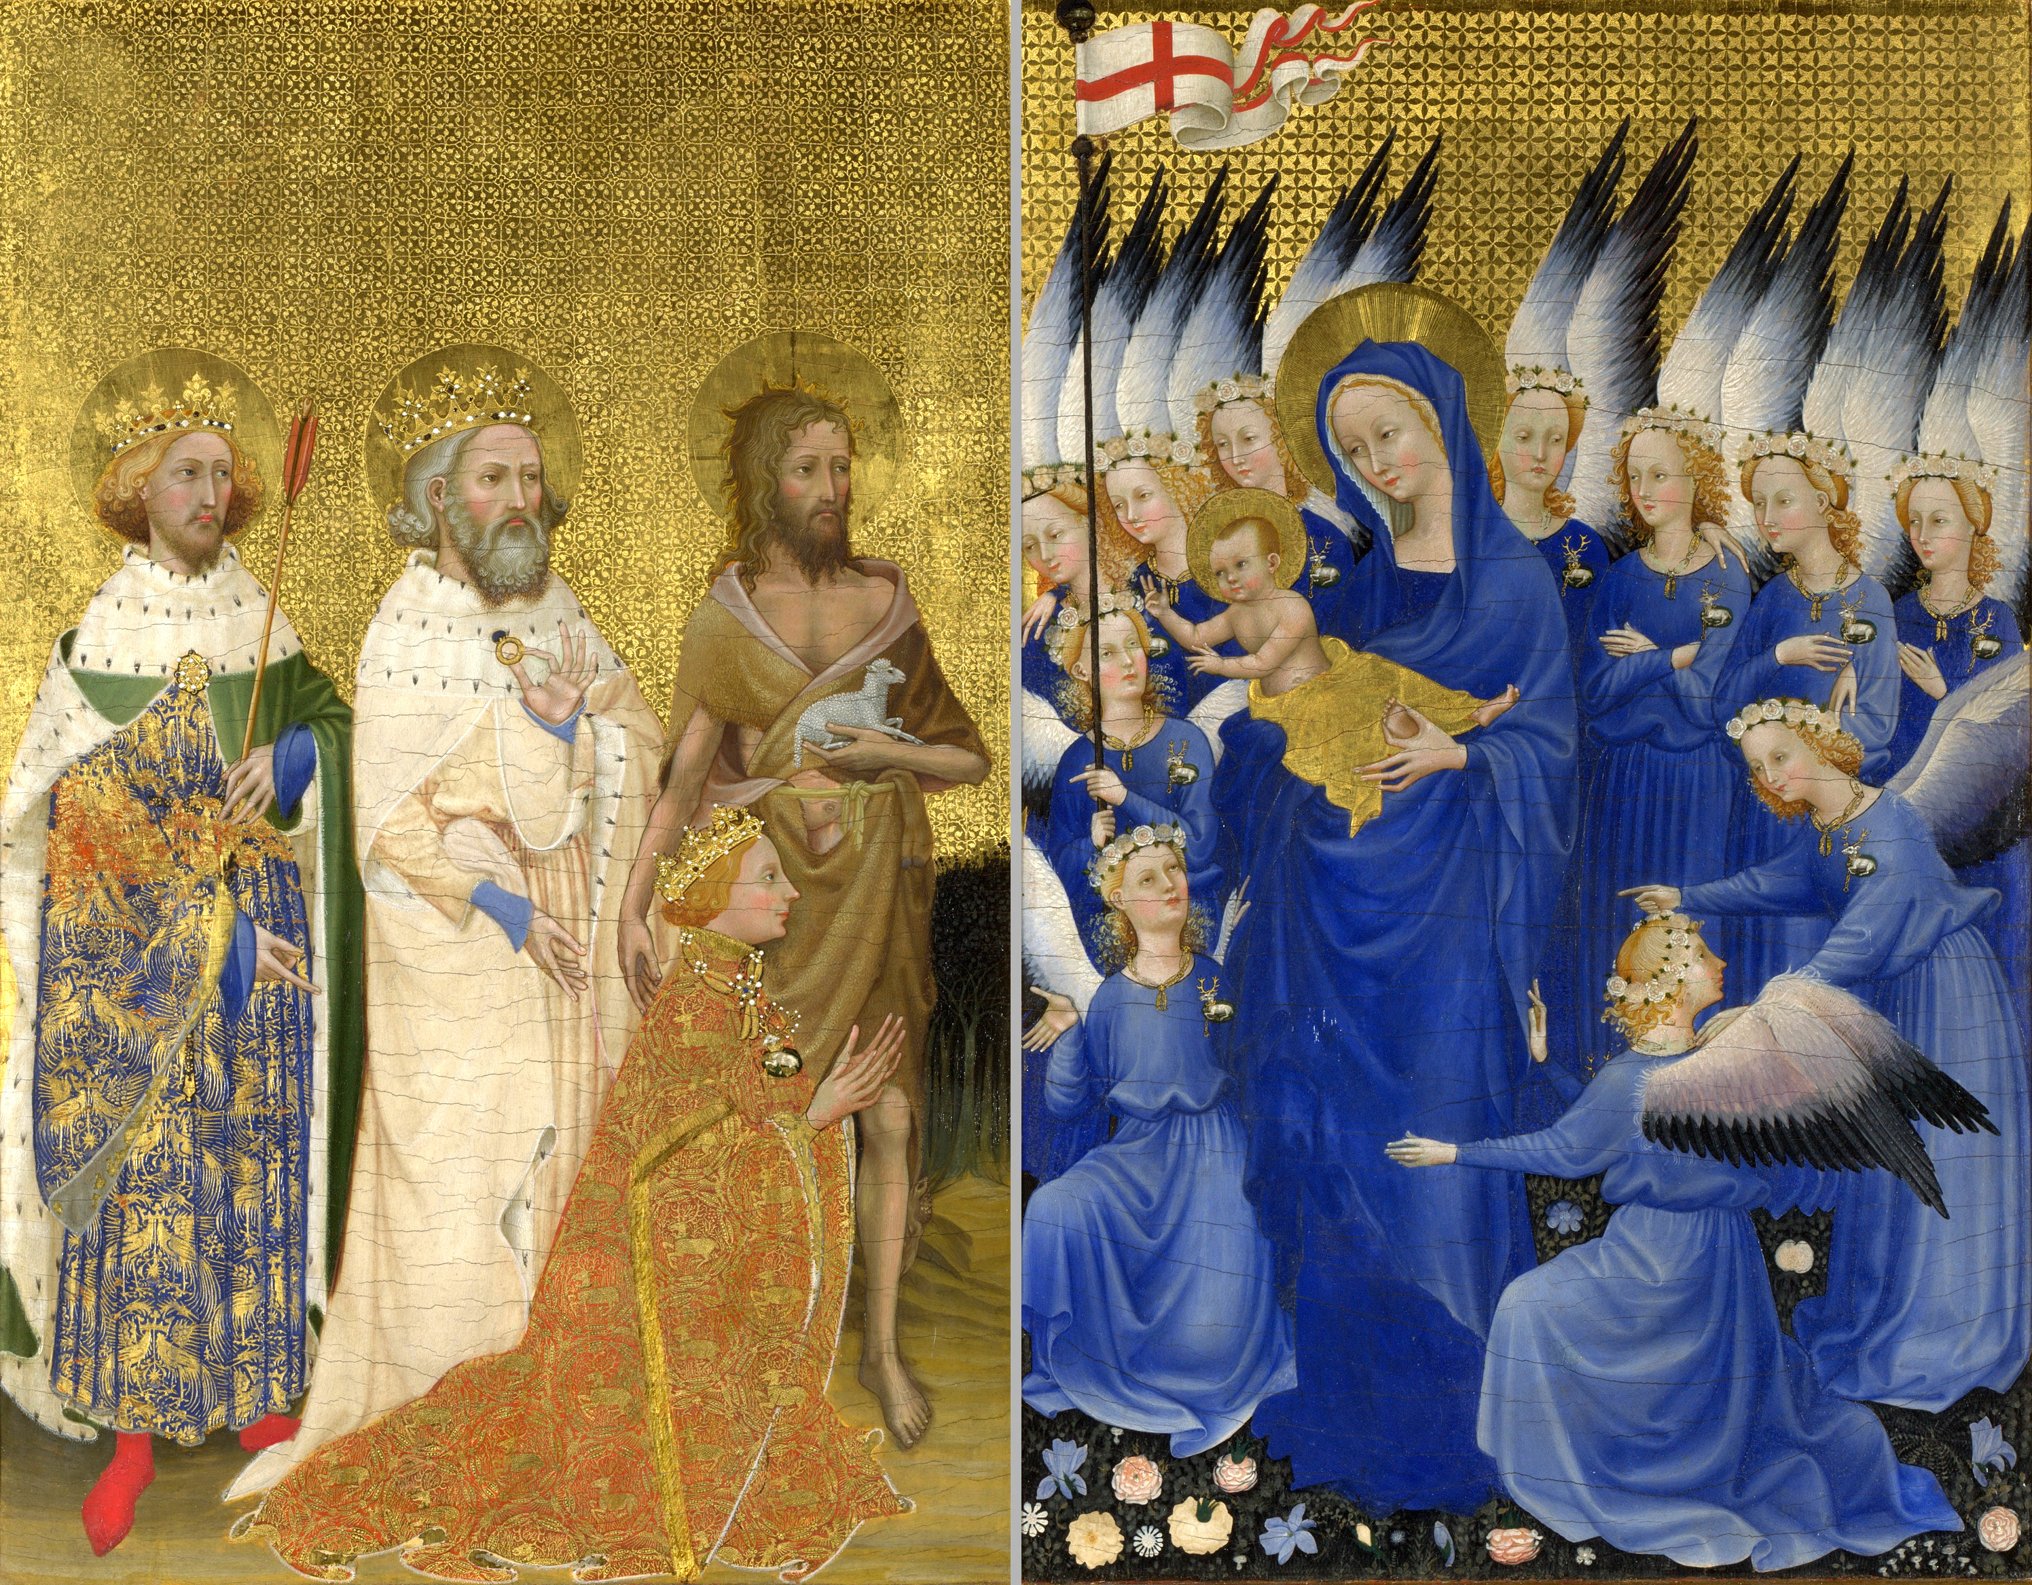
The use or usability of artwork during this period is particularly interesting. Due to the magnificence of these works, it is perhaps easy for modern viewers to interact with these objects without recognizing their original utility. The diptych, for example, served as a portable devotional object that both suggested the owner's social status and his or her piety. Perhaps the best example of this is The Virgin of Jeanne d'Evreux, a reliquary in France. The work is a beautiful example of the heavy layer of symbolism and theater that characterizes all mediums of the Gothic style. Despite the beauty of the sculptured elements, the work clearly has a specific function: it is a reliquary. A reliquary is essentially a special container, a box designed to house sacred relics (parts of holy objects or people). Like the decorated Cathedrals themselves, which signify holiness and concern for the immortal realm to the surrounding community through their outward appearance, reliquaries identify to the viewer that their contents are sacred. Thus, even as these works have a utilitarian purpose, they are designed to excite wonder and devotion in their regular users.
Video Transcript

We're in the Louvre in Paris, looking at an extraordinary sculpture from the first half of the 14th Century.
This is an incredibly luxurious object, it's made out of silver, covered in gold. Clearly this was made for someone very important and very wealthy.
In addition to the gold and silver, there's enamel, there are pearls, and there's crystal.
And she originally wore a crown on her head.
This was likely commissioned by the king of France, Charles IV, for his wife, Jeanne d'Evreux.
And so this is known as the Virgin of Jeanne d'Evreux, but this beautiful golden figure is more than a sculpture.
It's a reliquary. It was intended to hold sacred relics associated with the Virgin Mary. It was given to the abbey of St. Denis, just north of Paris. This was an especially important religious center. It was where the kings and queens of France were buried.
What makes this so typical of the Gothic period is the extraordinary tenderness we see between the mother and child. Earlier in the Gothic period, we saw Mary represented very frontally holding the Christ child, also positioned frontally, on her lap, but here Christ is propped up on her hip in a way that seems very natural.
And tenderly touching her mouth with his hand. The frontal image that you referred to comes out of the Byzantine tradition, but as the Virgin Mary gains increasing prominence in the medieval era, especially in western Europe, as the cult of the Virgin grows, there is the introduction of new ways of representing her.
Look at the Virgin's long neck and the way that tilts gracefully toward the Christ child. In his left hand, he holds a pomegranate.
A symbol of resurrection, recalling not the beginning of his life but the end.
Which is not unusual in the images of the Virgin and child; we frequently see a foreshadowing of Christ's suffering and death on the cross.
But if it wasn't for the pomegranate, we would have no inkling of that terrible end, because there seems to be nothing but tenderness that's represented here. We see this increasing interest in human emotion, in human interaction, here in this small statuette but we also see it on the Gothic cathedrals that were built in and around Paris.
And in fact, in Notre Dame de Paris, the major cathedral in the city itself, there is a large sculpture that looks quite similar to this. It has the same emphasis on an elegant drapery, on an elegant sway to the body, especially the jutting hip, and we see it in the manuscript that had also been owned by this queen that is now in the collection of the Metropolitan Museum of Art, in one particular elimination that shows the Annunciation.
To me, the sway of the body gives the figure a sense of movement and animation that's incredibly lifelike, but we shouldn't confuse this with the later contrapposto that develops in the Renaissance, or that we see in ancient Greek, in Roman sculpture, where we clearly see a bent knee pressing through the drapery and a figure that's in correct proportion. This figure is very elongated, and that sway is not so much created by a body that's realistic, but instead on this very complicated curving of the drapery.
The metal workers who produced this were taking great care with that drapery. I'm particularly fond of the way that her sleeve wraps over her arm.
And I like the way it pulls down at her feet. If we go to the Virgin's left side, there's this wonderful passage of drapery where it forms a zig-zag pattern down her legs. The figure stands on a base that is itself a work of art.
The base is carried by four lions, and then we see figures in niches and these frame enamel scenes showing moments from the life of Christ. So for example, we see the Annunciation, where the angel Gabriel tells Mary that she will conceive Christ, and then as we move around the reliquary, we get the scenes of the crucifixion and the resurrection of Christ.
Enamel is the addition of usually ground colored glass that's heated on a metal surface and adheres to that surface and creates these lovely deep colors in this case.
And it makes sense to me that the prophets are on the base that the Virgin Mary stands on. The prophets are figures from the Old Testament who, according to Christian tradition, foretell the coming of Christ, and above we see Mary holding the Christ child. The sumptuousness of this sculpture creates a clear relationship between the political power of the king and queen of France and the spiritual power that the Virgin Mary and Christ represent.

Questions to Consider
- How is the Gothic interest in personal devotion manifest in this work?
- How does the form of the images differ from early periods? What makes the International Gothic style distinct?

The Arena (Scrovegni) Chapel
The Gothic period makes a quiet and almost imperceptible transition to the Renaissance, whose origins are placed around 1400. Nevertheless, as early as the late 1200s, we see changes in painting and sculpture that lay the foundation for what we will come to recognize as the Renaissance. Some scholars call this early period the “Late Gothic"—a term which refers to the late Middle Ages, while other people call it the “Proto-Renaissance”—the beginnings of the Renaissance. In any case, a revolution is beginning to take place in Italy in the early 1300s in the way people think about the world, the way they think about the past, and the way they think about themselves and their relationship with God.

Giotto
The artist who takes the biggest step away from the medieval style of spiritual representation in painting in the early 14th century is Giotto.
Giotto is perhaps best known for the frescoes he painted in the Arena (or Scrovegni) Chapel. They were commissioned by a wealthy man named Enrico Scrovegni, the son of a well-known banker (and a banker himself). According to the Church, usury (charging interest for a loan) was a sin, and so perhaps one of Enrico’s motivations for building the chapel and having it decorated by Giotto was to atone for the sin of usury. The chapel is known as the Arena Chapel since it is on the site of an ancient Roman arena (or amphitheater) that later became the property of Scrovegni, whose palace abutted the chapel (the palace was torn down in the 19th century, though parts of the arena remain).
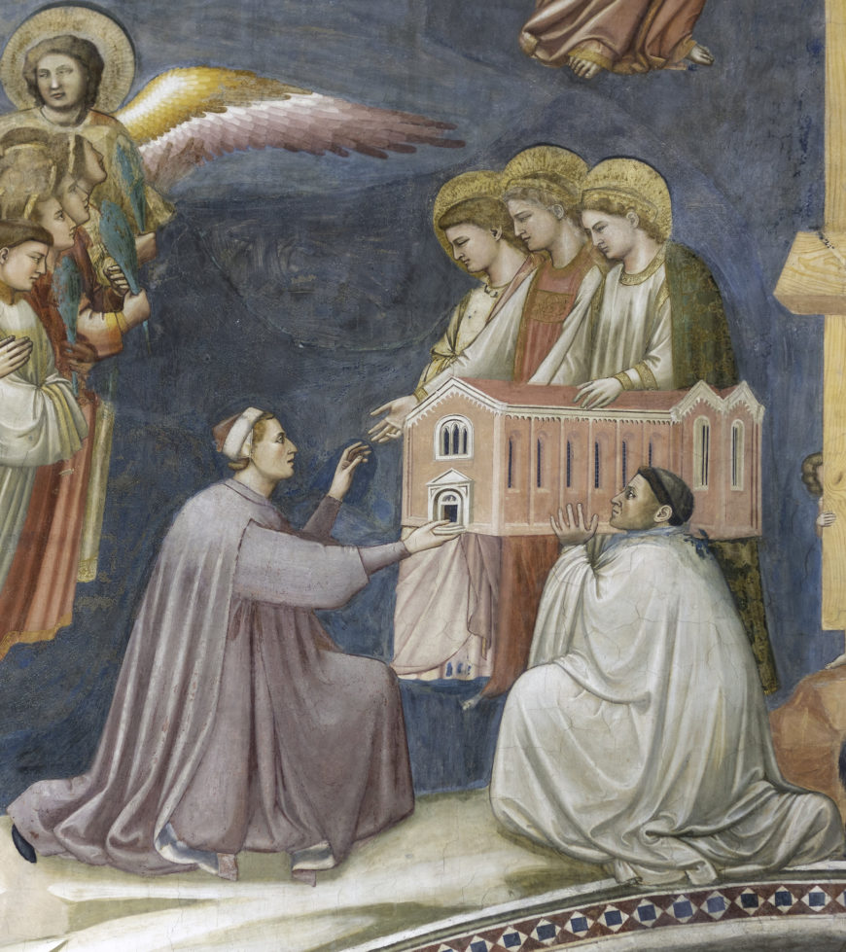
Commissioning works of art for churches was a common way of doing “good works,” which could help you earn your way into heaven. We can see Enrico himself in the fresco of the Last Judgment on the west wall of the Arena Chapel—he is shown on the side of the blessed (or the elect, those whom Christ has chosen to go to heaven). He is depicted kneeling, presenting the chapel to the Virgin Mary and two other figures (variously identified).
Because frescoes are painted directly on the wall, they can’t easily be moved and put in a museum. Most frescoes are, therefore, still in the spaces that the artists created them in and that the patrons commissioned them for. Having the work of art in its original context helps us to understand its meaning for the people of the 14th century. The frescoes in this chapel tell the story of the lives of Mary (beginning with her parents, Joachim and Anna) and Christ on the long walls. By the altar, Giotto painted the Annunciation, and at the other end, on the entrance wall, the Last Judgment.
Rather like a comic book without words, Giotto tells the story of Christ and his parents through pictures. Most of the population of Europe was illiterate at this time and so couldn’t read the Bible for themselves (Bibles were rare and expensive in any case—there was no printing press and so each was copied by hand). People learned the stories of the Bible—stories that would help them get to heaven—by hearing the words of the priest in the church, and by looking at paintings and sculptures.
Video Transcript
We're in the Arena Chapel, a small private chapel that was connected to a palace that was owned by the Scrovegni Family.
And it was the Scrovegni Family who commissioned Giotto to decorate this chapel with frescoes.
It's called the Arena Chapel because it's next to ancient Roman arena.
When you're inside it, as we are now, I have to say that it's taller than I expected and that feeling of being enclosed by images that happens when you're in a space entirely covered with fresco.
There are lots of narrative scenes, but even in between those scenes are trompe l'oeil faux marble panels and we get the sense that there is inlaid stone, but in fact, this is all painting.
And that extends even onto the ceiling, where we have a star-studded blue sky with images of Christ and Mary and other saints and figures. The Arena Chapel is organized in a very strict way. Three registers begin at the top and move downward. I think of it as a spiral, that is it tells a continuous story. It begins with Christ's grandparents. It goes into the birth of Mary, her marriage, and then when we get down to the second register we get to Christ's life or ministry, and then the bottom register is the Passion. These are the events at the end of Christ's life and immediately after his death.
Now all of this is thanks to, strangely it might seem to us today, a sin: the sin of usury that weighed heavily on the conscience of Enrico Scrovegni, whose palace was next door and who owned this land and built this chapel and hired Giotto. His father was a usurer. Enrico himself was a usurer.
What this means is he charged interest, just like when you borrow money from a bank you're charged interest, when you put money on a credit card you're charged interest, and so in a very Catholic environment, being a banker made you a lot of money, but it also, in your belief system, would send you to hell.
And Dante, the great late medieval poet, in his most famous poem, The Divine Comedy, singles out Scrovegni's father for one of the more treacherous parts of hell.
So Enrico was really worried, and for this reason, he did, in Catholic belief system, a good work. He built this chapel. This was his way of atoning for the sin of usury, hoping that this would help his soul to go to heaven. And we see Enrico himself here in this chapel on the wall over the entrance where Giotto painted the last judgment. We see Enrico kneeling, handing the chapel over.
To the three Marys, the Virgin Mary in the middle.
Notice where Enrico has put himself is on the side of the blessed. In the last judgment, we see Christ at the very top, and the damned are on Christ's left and the blessed are on Christ's right, and that's where we find Enrico. And the impetus for the entire cycle can be seen at the apex of the triumphal arch on the opposite wall with God, who calls Gabriel to his side, telling him to go to the Virgin Mary and announce to her that she will bear humanity's savior, that she will bear Christ.
Interestingly, when Giotto painted God, he inserted a panel painting. So that is not fresco. It's interesting that he chose to paint it in the style that was more conservative, less earthly than the style that we see in the frescoes. But just to go back to that wall, we begin to see the illusionism that we see throughout the cycles. If we look to Mary and the angel, Giotto has created an architectural space for each of them. These are not panel paintings with gold backgrounds that suggest a divine space. These are earthly settings for Mary and the angel.
Two scenes below the Annunciation are these wonderful empty architectural spaces, these rooms that have oil lanterns that hang from their ceilings.
And there is such a delicate sense of space, of light and shadow. It is this bravura example of naturalism, and it shows Giotto's interest in the world, the present, the physical space that humanity occupies.

Read this online at https://open.byu.edu/history_of_the_fine_arts_music/gothic_art

